Design, synthesis in vitro and in vivo evaluation of new diaryltriazoles carboxylic and hydroxamic acid derivatives as inhibitors of tumor necrosis alpha converting enzyme (TACE)
Abdelfattah Hassan^{1*}, Mostafa M. Badran¹, Heba A. Hassan², Dalia Abdelhamed², and Omar M. Aly ³
¹ Medicinal Chemistry Department, Faculty of Pharmacy, South Valley University, Qena, Egypt.
² Medicinal Chemistry Department, Faculty of Pharmacy, Minia University, Minia, Egypt.
³ Medicinal Chemistry Department, Faculty of Pharmacy, Port Said University, Egypt.
*Correspondence: abdelfattah_hassan@svu.edu.eg, +201000760083

Figure No |  | Page No.
Table 2 | The anti-inflammatory activity of compounds 4a-x, 5a-x and 6a-b using carrageenan-induced paw edema in rats | 6
Table 3 | Ulcer indices measured post administration of compounds 4a-d, 4f-x,  5a-x and 6a,b compared to indomethacin and celecoxib | 7
1 | ¹H-NMR spectrum of compound 4a (CDCl₃) | 9
2 | ¹³C NMR spectrum of compound 4a (CDCl₃) | 10
3 | HRMS of compound 4a
4 | ¹H-NMR spectrum of compound 4b (CDCl₃). | 11
5 | HRMS of compound 4a | 12
6 | ¹H-NMR spectrum of compound 4c (DMSO-d₆). | 13
7 | ¹³C-NMR spectrum of compound 4c (DMSO-d₆). | 14
8 | ¹H-NMR spectrum of compound 4d (DMSO-d₆) | 15
9 | ¹³C-NMR spectrum of compound 4d (CDCl₃) | 16
10 | HRMS of compound 4d | 17
11 | ¹H-NMR spectrum of compound 4e (DMSO-d₆) | 18
12 | ¹³C-NMR spectrum of compound 4e (DMSO-d₆) | 19
13 | HRMS of compound 4e | 20
14 | ¹H-NMR spectrum of compound 4f (CDCl₃). | 21
15 | ¹³C-NMR spectrum of compound 4f (CDCl₃) | 22
16 | HRMS of compound 4f | 23
17 | ¹H-NMR spectrum of compound 4g (CDCl₃) | 24
18 | ¹³C-NMR spectrum of compound 4g (CDCl₃) | 25
19 | HRMS of compound 4g | 26
`20 | ¹H-NMR spectrum of compound 4h (CDCl₃) | 27
21 | ¹³C-NMR spectrum of compound 4h (CDCl₃) | 28
22 | HRMS of compound 4h | 29
23 | ¹H-NMR spectrum of compound 4i (CDCl₃) | 30
24 | ¹³C-NMR spectrum of compound 4i (CDCl₃) | 31
25 | HRMS of compound 4i | 32
26 | ¹H-NMR spectrum of compound 4j (CDCl₃) | 33
27 | ¹³C-NMR spectrum of compound 4j (CDCl₃) | 34
28 | HRMS of compound 4j | 35
29 | ¹H-NMR spectrum of compound 4k (CDCl₃) | 36
30 | ¹³C-NMR spectrum of compound 4k (CDCl₃) | 37
31 | HRMS of compound 4k | 38
32 | ¹H-NMR spectrum of compound 4l (CDCl₃) | 39
33 | ¹³C-NMR spectrum of compound 4l (DMSO-d₆) | 40
34 | HRMS of compound 4l | 41
35 | ¹³C-NMR spectrum of compound 4m (DMSO-d₆) | 42
36 | ¹H NMR of compound 9r (500 MHz, DMSO-d₆) | 43
37 | HRMS of compound 4m | 44
38 | ¹H-NMR spectrum of compound 4n (CDCl₃) | 45
39 | ¹³C-NMR spectrum of compound 4n (DMSO-d₆) | 46
40 | HRMS of compound 4n | 47
41 | ¹H-NMR spectrum of compound 4o (DMSO-d₆) | 48
42 | ¹³C-NMR spectrum of compound 4o (DMSO-d₆) | 49
43 | HRMS of compound 4o | 50
44 | ¹³C-NMR spectrum of compound 4p (DMSO-d₆) | 51
45 | HRMS of compound 4p | 52
46 | ¹H-NMR spectrum of compound 4q (CDCl₃) | 53
47 | ¹³C-NMR spectrum of compound 4q (DMSO-d₆) | 54
48 | HRMS of compound 4q | 55
49 | ¹H-NMR spectrum of compound 4r (CDCl₃) | 56
50 | ¹³C-NMR spectrum of compound 4r (CDCl₃) | 57
51 | HRMS of compound 4r | 58
52 | ¹H-NMR spectrum of compound 4s (CDCl₃) | 59
53 | ¹³C-NMR spectrum of compound 4s (CDCl₃) | 60
54 | HRMS of compound 4s | 61
55 | ¹H-NMR spectrum of compound 4t (CDCl₃) | 62
56 | ¹³C-NMR spectrum of compound 4t (CDCl₃) | 63
57 | HRMS of compound 4t | 64
58 | ¹H-NMR spectrum of compound 4u (DMSO-d₆) | 65
59 | ¹³C-NMR spectrum of compound 4u (CDCl₃) | 66
60 | HRMS of compound 4u | 67
61 | ¹H-NMR spectrum of compound 4v (CDCl₃) | 68
62 | ¹³C-NMR spectrum of compound 4v (DMSO-d₆) | 69
63 | HRMS of compound 4v | 70
64 | ¹H-NMR spectrum of compound 4w (CDCl₃) | 71
65 | ¹³C-NMR spectrum of compound 4w (CDCl₃) | 72
66 | HRMS of compound 4w | 73
67 | ¹H-NMR spectrum of compound 4x (DMSO-d₆) | 74
68 | ¹³C-NMR spectrum of compound 4x (DMSO-d₆) | 75
69 | HRMS of compound 4x | 76
70 | ¹H-NMR spectrum of compound 5a (CDCl₃) | 77
71 | ¹H-NMR spectrum of compound 5b (DMSO-d₆) | 78
72 | ¹H NMR spectrum of compound 5c (DMSO-d₆) | 79
73 | ¹H-NMR spectrum of compound 5d (DMSO-d₆) | 80
74 | ¹H-NMR spectrum of compound 5e (DMSO-d₆) | 81
75 | ¹H-NMR spectrum of compound 5f (DMSO-d₆) | 82
76 | ¹H-NMR spectrum of compound 5g (DMSO-d₆) | 83
77 | ¹H-NMR spectrum of compound 5h (DMSO-d₆) | 84
78 | ¹H-NMR spectrum of compound 5i (CDCl₃) | 85
79 | ¹³C-NMR spectrum of compound 5i (CDCl₃) | 86
80 | ¹H-NMR spectrum of compound 5j (CDCl₃) | 87
81 | ¹³C-NMR spectrum of compound 5j (CDCl₃) | 88
82 | ¹H-NMR spectrum of compound 5k (CDCl₃) | 89
83 | ¹³C-NMR spectrum of compound 5k (CDCl₃) | 90
84 | ¹H-NMR spectrum of compound 5l (DMSO-d₆) | 91
85 | ¹³C-NMR spectrum of compound 5l (DMSO-d₆) | 92
86 | ¹H-NMR spectrum of compound 5m (DMSO-d₆) | 93
87 | ¹³C-NMR spectrum of compound 5m (DMSO-d₆) | 94
88 | ¹³C-NMR spectrum of compound 5n (DMSO-d₆) | 95
89 | ¹H-NMR spectrum of compound 5o (DMSO-d₆) | 96
90 | ¹³C-NMR spectrum of compound 5o (CDCl₃) | 97
91 | ¹H-NMR spectrum of compound 5p (DMSO-d₆) | 98
92 | ¹³C-NMR spectrum of compound 5p (DMSO-d₆) | 99
93 | ¹H-NMR spectrum of compound 5q (DMSO-d₆) | 100
94 | ¹³C-NMR spectrum of compound 5q (DMSO-d₆) | 101
95 | ¹H-NMR spectrum of compound 5r (DMSO-d₆) | 102
96 | ¹³C-NMR spectrum of compound 5r (DMSO-d₆) | 103
97 | ¹H-NMR spectrum of compound 5s (CDCl₃) | 104
98 | ¹³C-NMR spectrum of compound 5s (CDCl₃) | 105
99 | ¹H-NMR spectrum of compound 5t (DMSO-d₆) | 106
100 | ¹³C-NMR spectrum of compound 5t (CDCl₃) | 107
101 | ¹H-NMR spectrum of compound 5u (DMSO-d₆) | 108
102 | ¹³C-NMR spectrum of compound 5u (DMSO-d₆) | 109
103 | ¹H-NMR spectrum of compound 5v (DMSO-d₆) | 110
104 | ¹³C-NMR spectrum of compound 5v (DMSO-d₆) | 112
105 | ¹H-NMR spectrum of compound 5w (DMSO-d₆) | 113
106 | ¹³C-NMR spectrum of compound 5w (DMSO-d₆) | 114
107 | ¹H-NMR spectrum of compound 5x (DMSO-d₆) | 115
108 | ¹³C-NMR spectrum of compound 5x (CDCl₃) | 116
109 | ¹H-NMR spectrum of compound 6a (CDCl₃) | 117
110 | ¹³C-NMR spectrum of compound 6a (CDCl₃) | 118
111 | HRMS of compound 6a | 119
112 | ¹H-NMR spectrum of compound 6b (CDCl₃) | 120
113 | ¹³C-NMR spectrum of compound 6b (CDCl₃) | 121
114 | HRMS of compound 6b | 122

Table 2. The percent anti-inflammatory activity of compounds 4a-x, 5a-x and 6a-b relative to indomethacin using carrageenan-induced paw edema in rats.
 | % Activity relative to indomethacin
 | 3 hr | 4 hr |  | 3 hr | 4 hr
4a | 76.47% | 80.00% | 5d | 88.24% | 80.00%
4b | 82.40% | 75.04% | 5e | 100.00% | 80.00%
4c | 88.24% | 85.00% | 5f | 100.00% | 80.00%
4d | 76.47% | 80.00% | 5g | 82.35% | 75.00%
4f | 73.53% | 91.35% | 5h | 96.11% | 67.26%
4i | 18.38 | 10.42 | 5i | 98.04 | 97.22
4j | 70.59 | 65.00 | 5j | 36.76 | 36.46
4k | 67.87 | 91.35 | 5k | 90.50 | 86.54
4l | 73.53 | 57.29 | 5l | 83.33 | 83.33
4m | 107.47 | 96.15 | 5m | 41.18 | 50.00
4n | 70.59 | 80.00 | 5n | 29.41 | 25.00
4o | 64.71 | 65.00 | 5o | 56.56 | 62.50
4p | 47.06 | 30.00 | 5p | 94.12 | 90.00
4q | 36.76 | 26.04 | 5q | 90.50 | 67.31
4r | 82.35 | 75.00 | 5r | 41.18 | 35.00
4s | 100.00 | 105.00 | 5s | 100.00 | 90.00
4t | 52.94 | 50.00 | 5t | 76.47 | 70.00
4u | 107.47 | 96.15 | 5u | 117.65 | 105.00
4v | 35.29 | 30.00 | 5v | 41.18 | 40.00
4w | 100.00 | 80.00 | 5w | 65.36 | 64.81
4x | 101.81 | 96.15 | 5x | 16.97 | 14.42
5a | 96.15% | 91.35% | 6a | 29.41 | 20.00
5b | 73.53% | 81.73% | 6b | 33.94 | 24.04
5c | 79.66% | 72.92%

Table 3. Ulcer indices measured post administration of compounds 4a-d, 4f-x,
5a-x and 6a,b compared to indomethacin and celecoxib.
Compound | UI  Mean± SE | Compound | UI  Mean± SE
Control | 0.6±0.24 | 4q | 0.4±0.24
Indomethacin | 29.8±1.02 | 4r | 0.4±0.24
Celecoxib | 0.4±0.24 | 4s | 0.6±0.24
4a | 0.8±0.018 | 4t | 0.6±0.24
4b | 0.4±0.022 | 4u | 1.2±0.20
4c | 0.4±.022 | 4v | 0.4±0.24
4d | 0.2±0.018 | 4w | 1.6±0.24
4f | 1±0.028 | 4x | 0.6±0.24
4i | 4.2±0.58 | 5a | 0.2±0.18
4j | 3.2±0.37 | 5b | 0±0
4k | 1.6±0.24 | 5c | 1±0.029
4l | 2.6±0.24 | 5d | 0±0
4m | 1.4±0.24 | 5e | 3.2±0.066
4n | 1±0.00 | 5f | 0.8±0.018
4o | 0.8±0.20 | 5g | 0.2±0.018
4p | 1.6±0.24 | 5h | 0.6±0.022
5i | 0.2±0.20 | 5r | 1.4±0.24
5j | 0.2±0.20 | 5s | 0.2±0.2
5k | 0.4±0.24 | 5t | 0.6±0.24
5l | 1.2±0.37 | 5u | 0.4±0.24
5m | 0.4±0.24 | 5v | 1.6±0.24
5n | 1.2±0.20 | 5w | 2±0.32
5o | 1.2±0.20 | 5x | 1±0.00
5p | 0.6±0.24 | 6a | 1.4±0.24
5q | 0.4±0.24 | 6b | 1.2±0.20

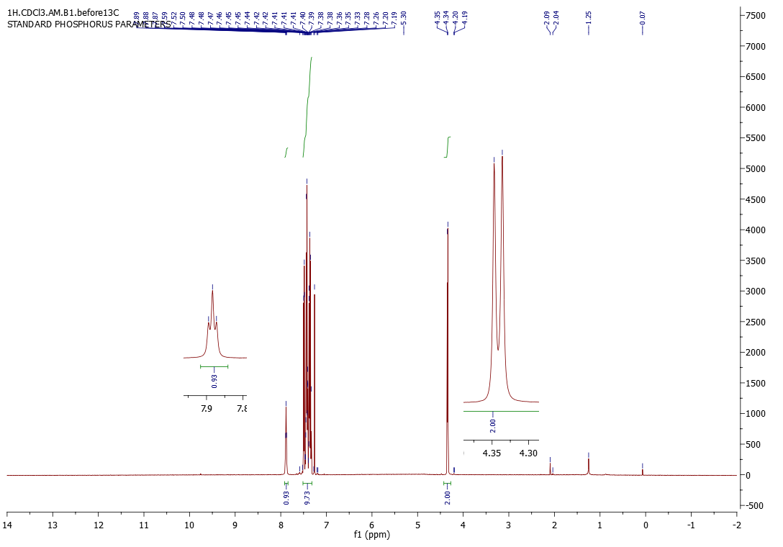
Fig. 1: ¹H-NMR spectrum of compound 4a (CDCl₃)

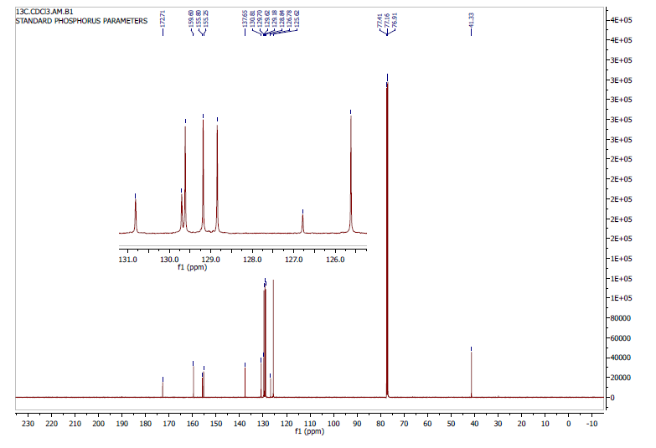 Fig. 2: ¹³C NMR spectrum of compound 4a (CDCl₃).
Fig. 3: HRMS of compound 4a
Fig. 4: ¹H-NMR spectrum of compound 4b (CDCl₃).
Fig. 5: HRMS of compound 4b

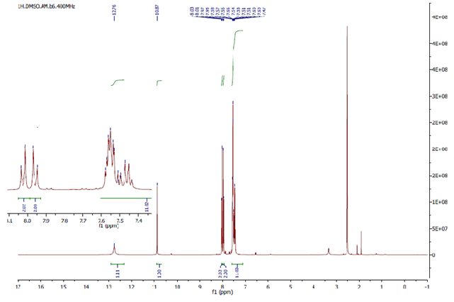
Fig. 6: ¹H-NMR spectrum of compound 4c (DMSO-d₆).

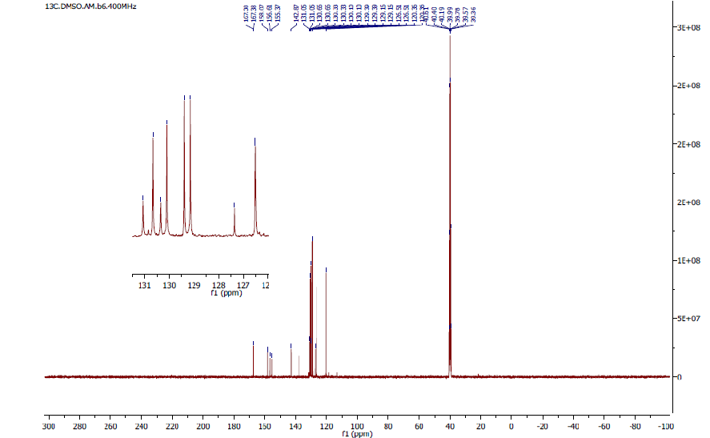Fig. 7: ¹³C-NMR spectrum of compound 4c (DMSO-d₆).

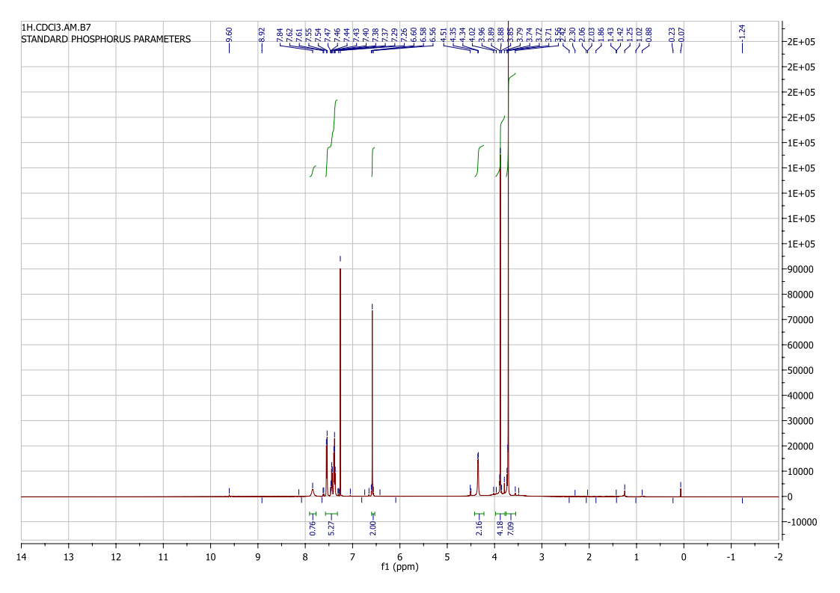
Fig. 8: ¹H-NMR spectrum of compound 4d (DMSO-d₆)

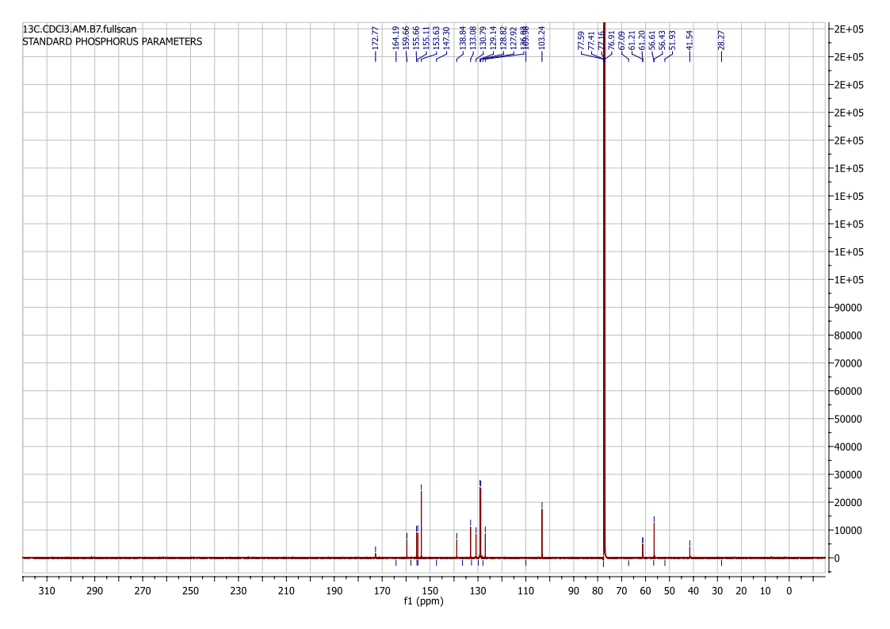
Fig. 9: ¹³C-NMR spectrum of compound 4d (CDCl₃)
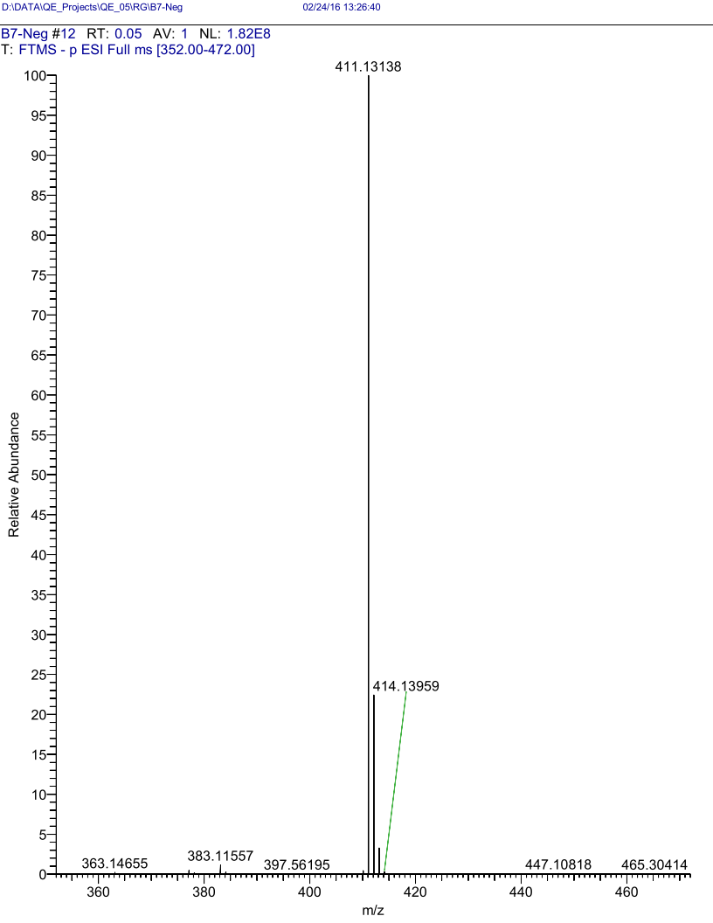
Fig. 10: HRMS of compound 4d
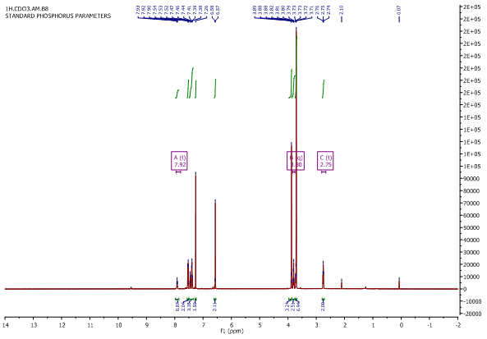
Fig. 11: ¹H-NMR spectrum of compound 4e (DMSO-d₆)

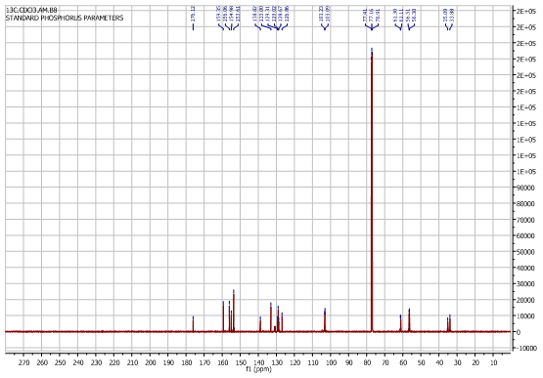
Fig. 12: ¹³C-NMR spectrum of compound 4e (DMSO-d₆)
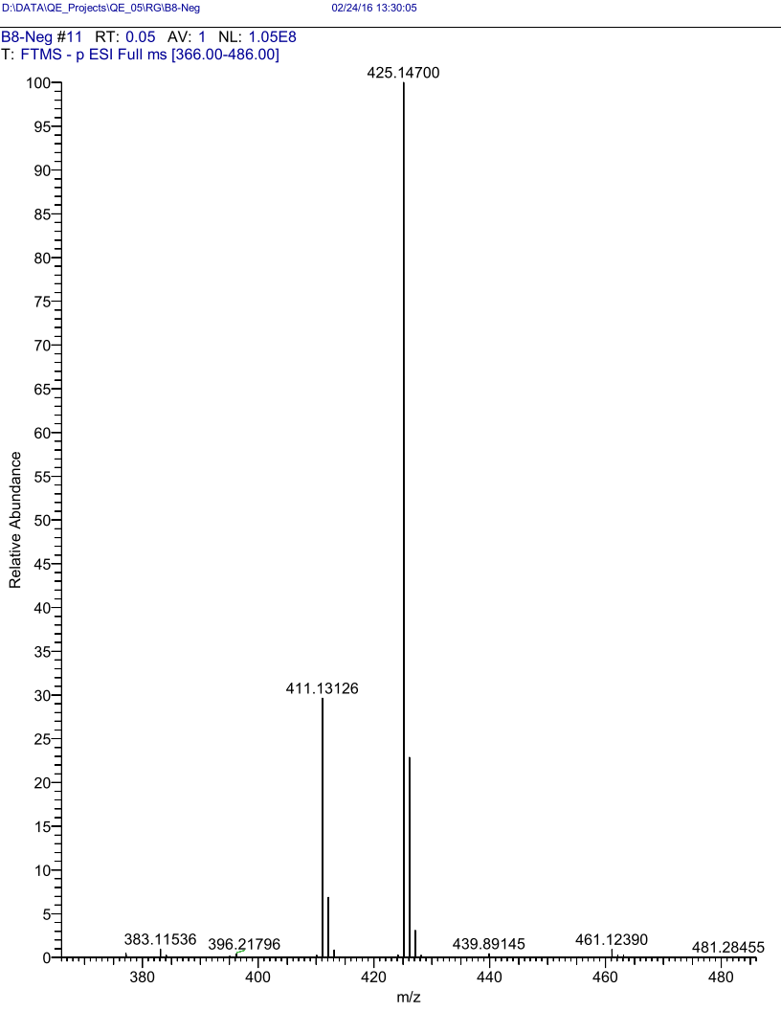
Fig. 13: HRMS of compound 4e

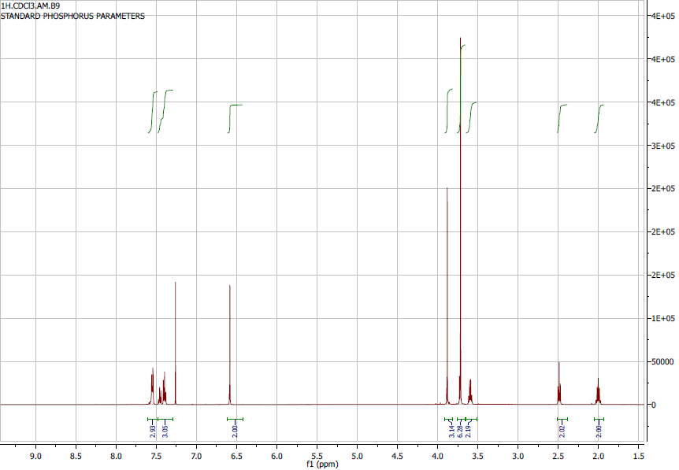
Fig. 14: ¹H-NMR spectrum of compound 4f (CDCl₃).

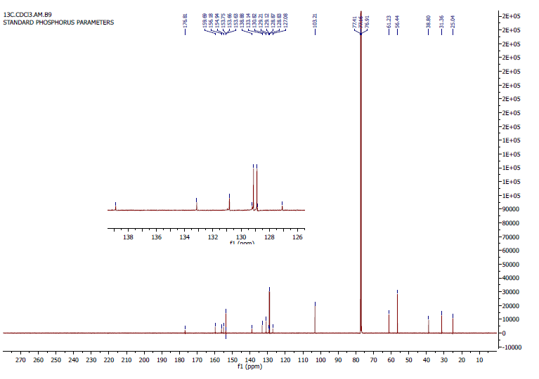
Fig. 15: ¹³C-NMR spectrum of compound 4f (CDCl₃)
Fig. 16: HRMS of compound 4f
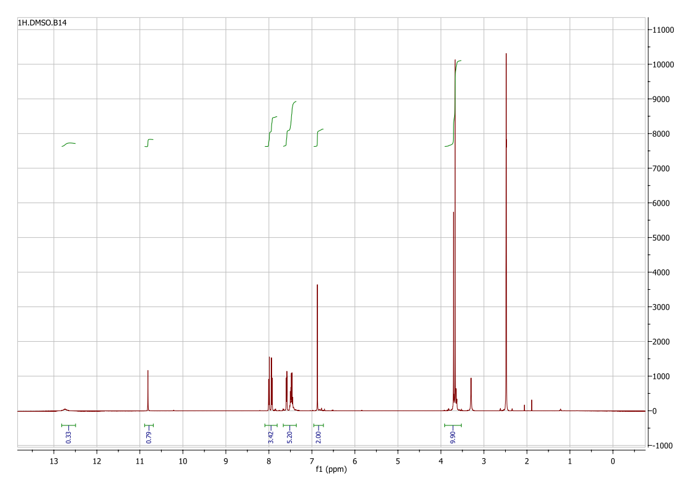
Fig. 17: ¹H-NMR spectrum of compound 4g (CDCl₃)

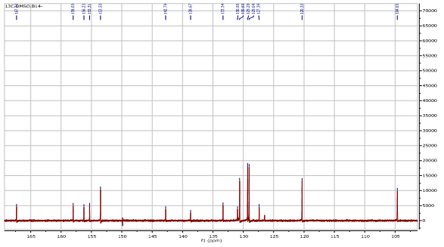 Fig. 18: ¹³C-NMR spectrum of compound 4g (CDCl₃)
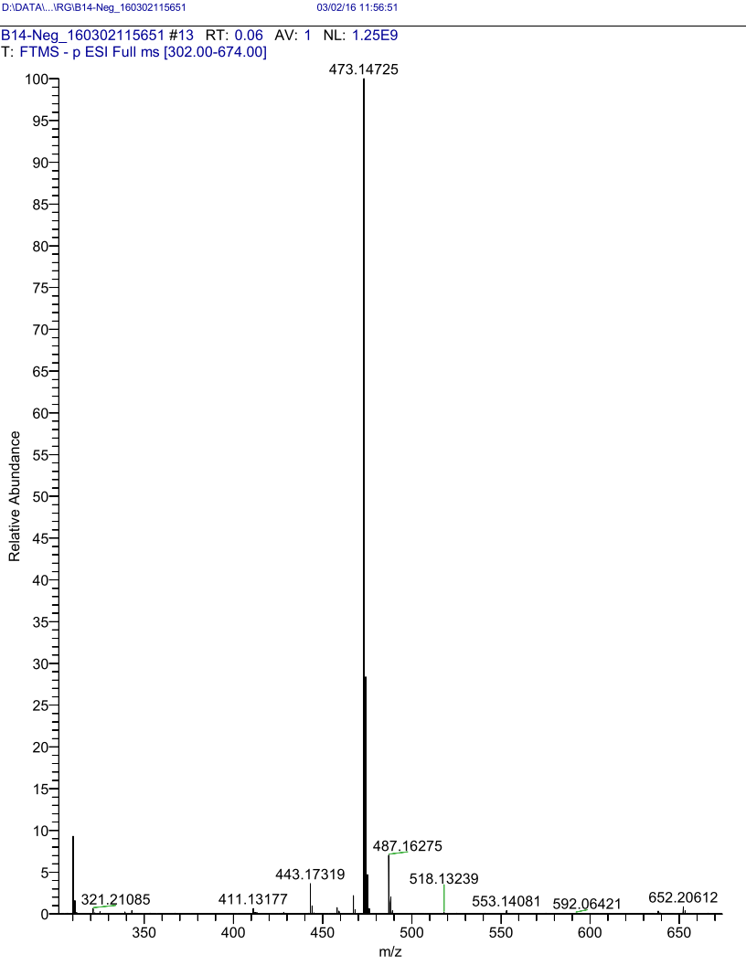
- Fig. 19: HRMS of compound 4g

- 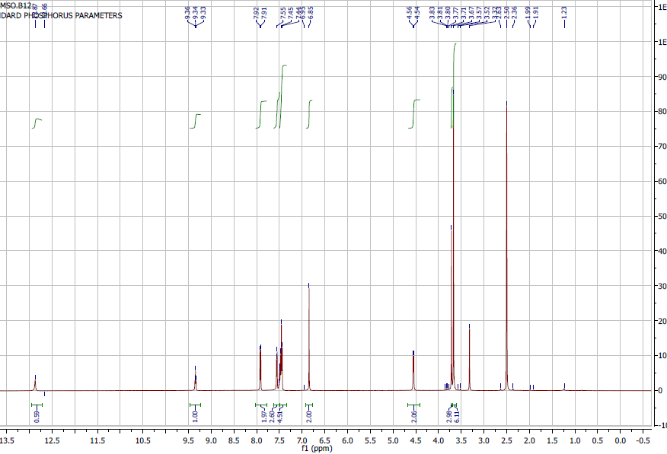Fig. 20 :¹H-NMR spectrum of compound 4h (CDCl₃)
- 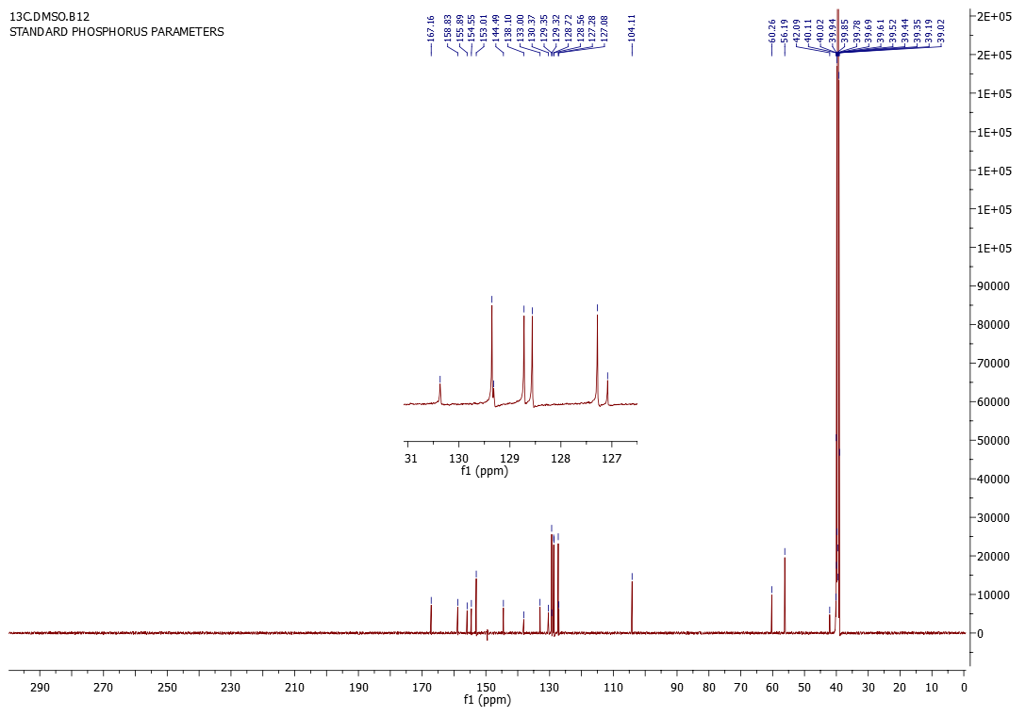
- Fig. 21: ¹³C-NMR spectrum of compound 4h (CDCl₃)
- Fig. 22: HRMS of compound 4h

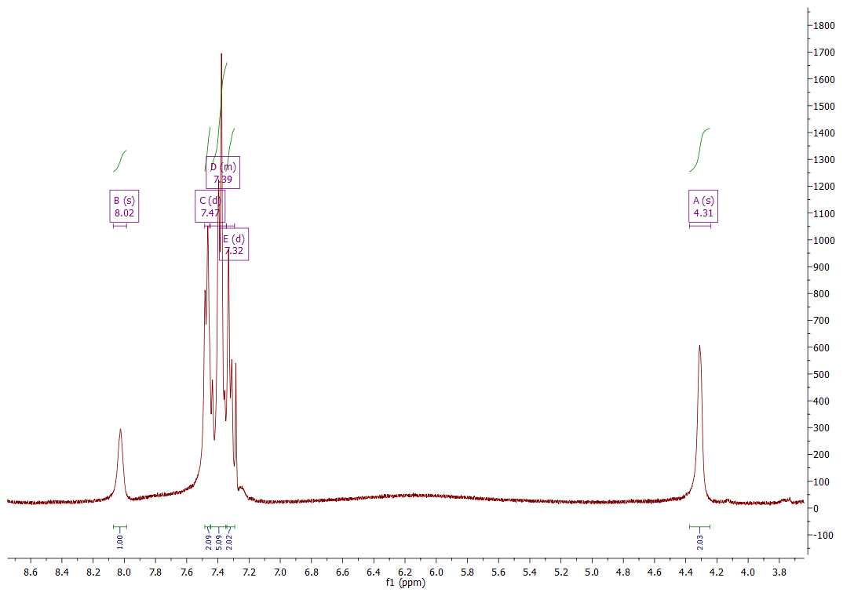
Fig. 23: ¹H-NMR spectrum of compound 4i (CDCl₃)
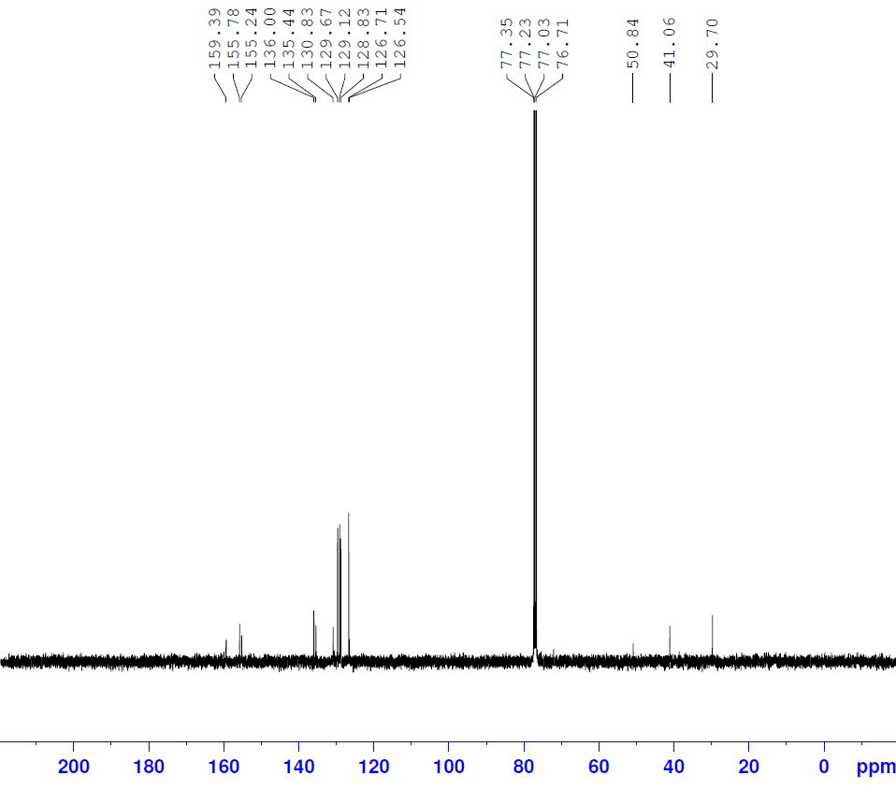
Fig. 24: ¹³C-NMR spectrum of compound 4i (CDCl₃)
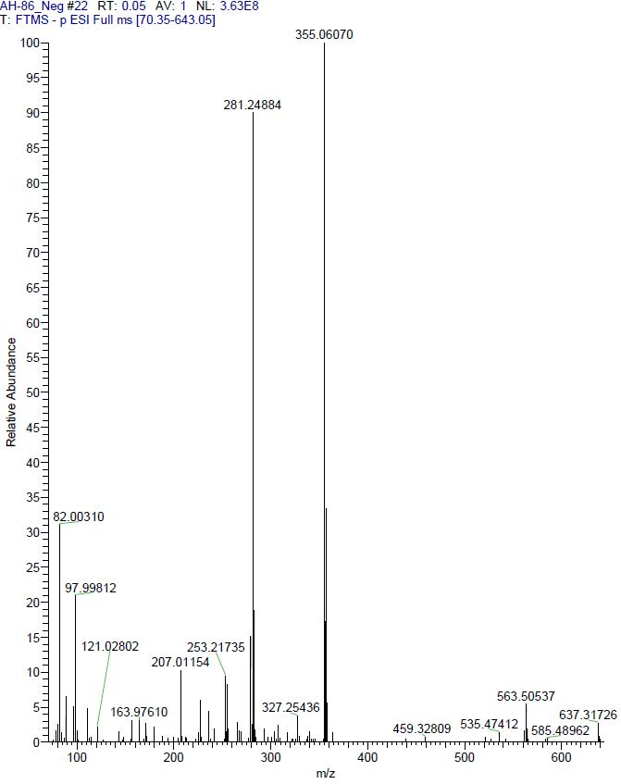
Fig. 25: HRMS of compound 4i
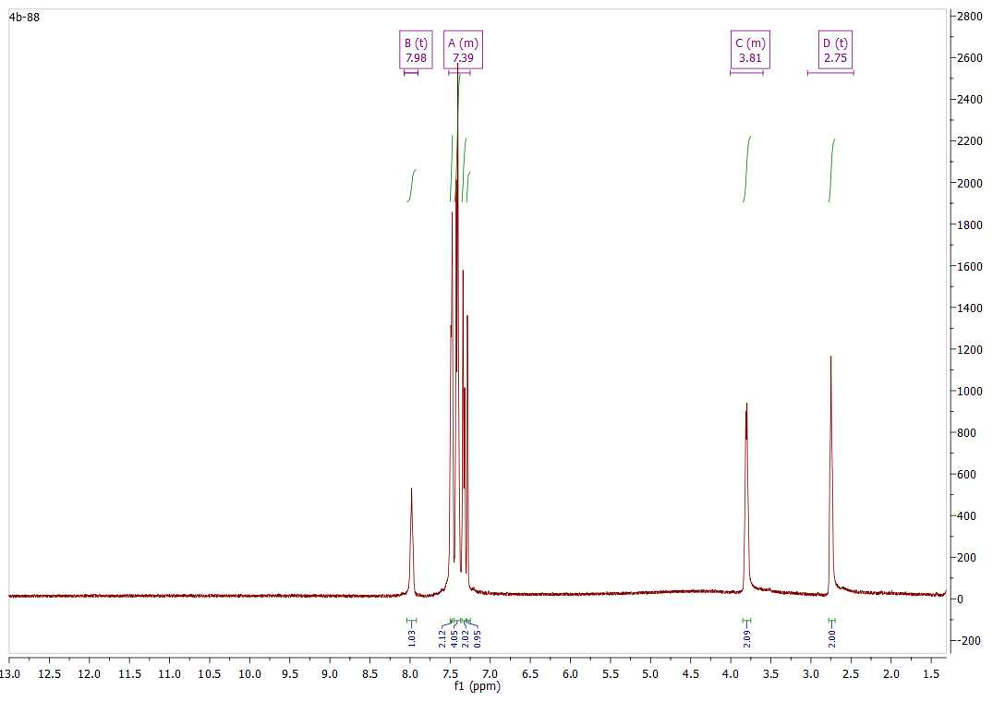
Fig. 26: ¹H-NMR spectrum of compound 4j (CDCl₃)
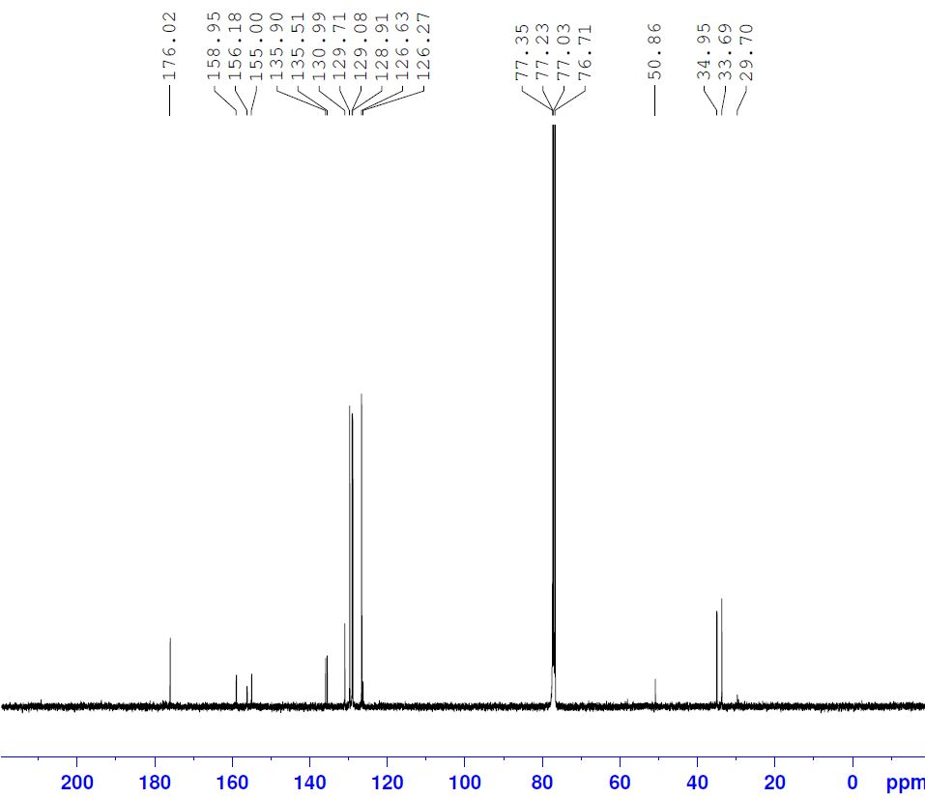
Fig. 27: ¹³C-NMR spectrum of compound 4j (CDCl₃)
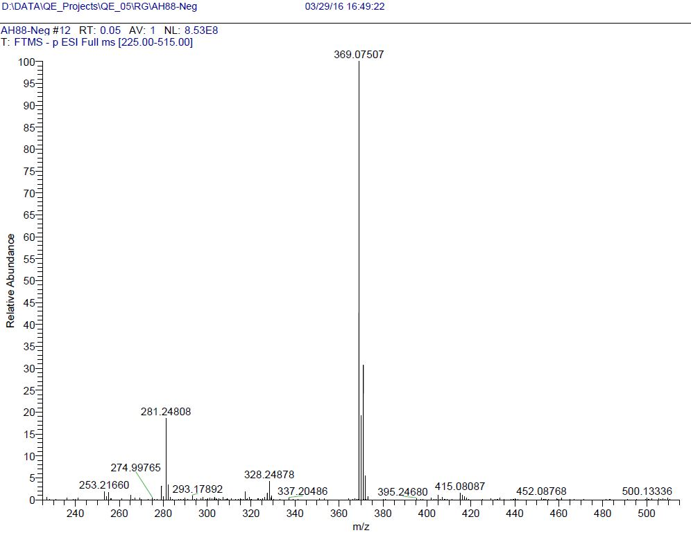
Fig. 28: HRMS of compound 4j

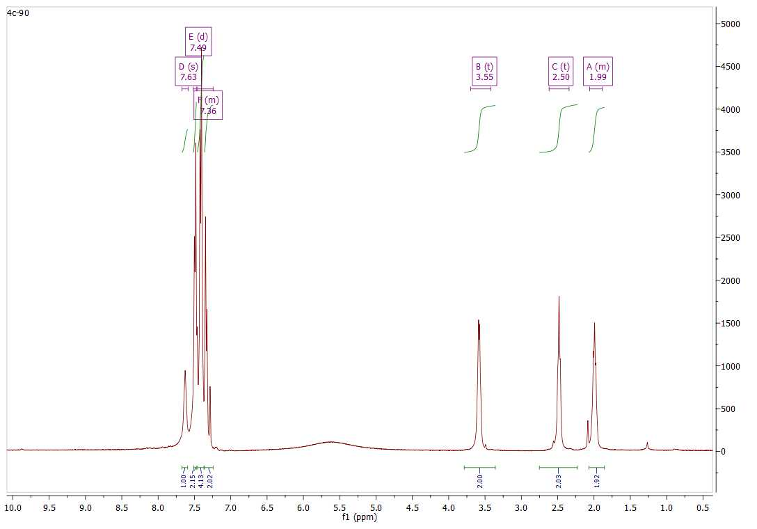
Fig. 29: ¹H-NMR spectrum of compound 4k (CDCl₃)

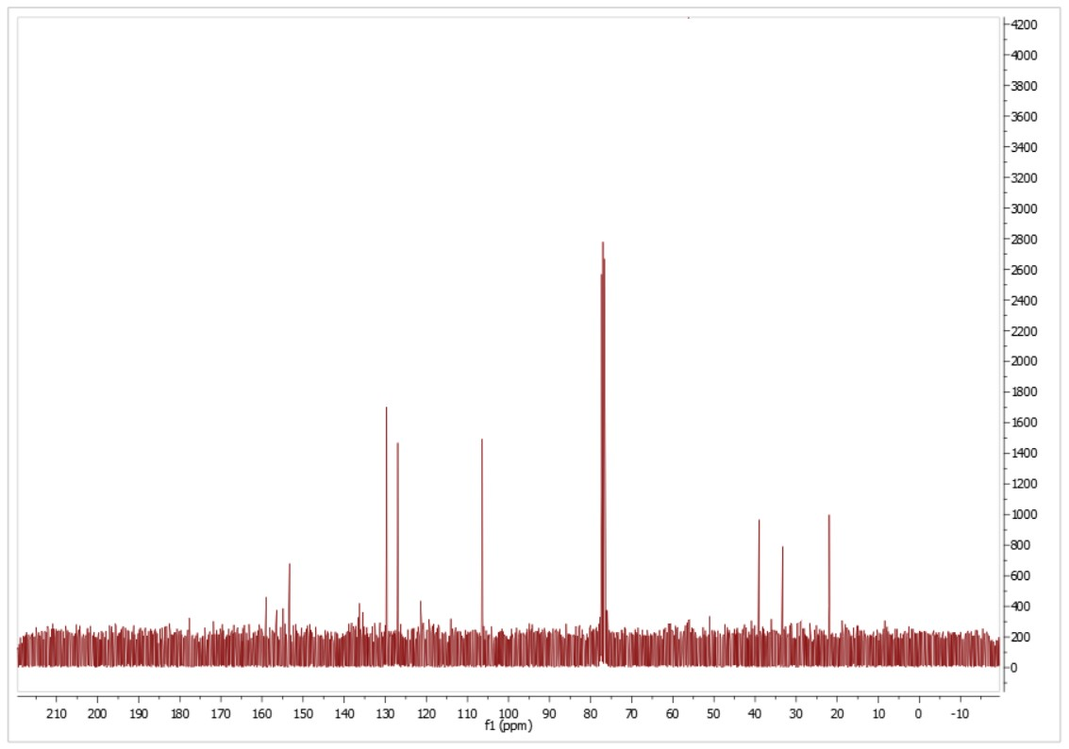
Fig. 30: ¹³C-NMR spectrum of compound 4k (CDCl₃)
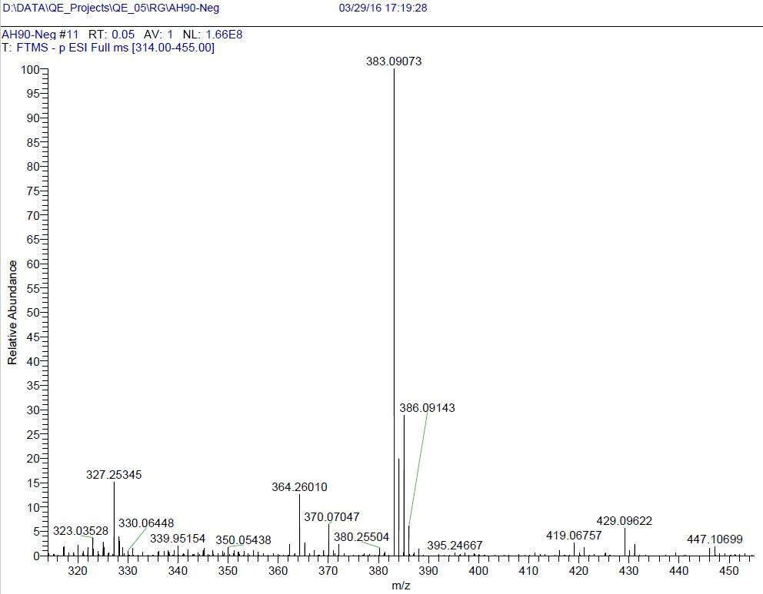
Fig. 31: HRMS of compound 4k

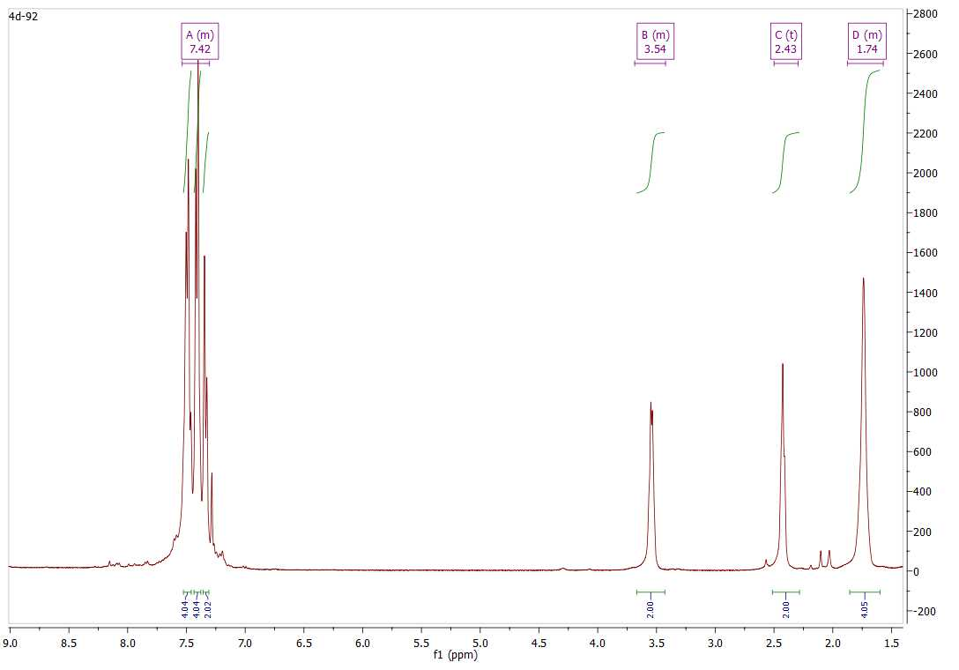
Fig. 32: ¹H-NMR spectrum of compound 4l (CDCl₃)
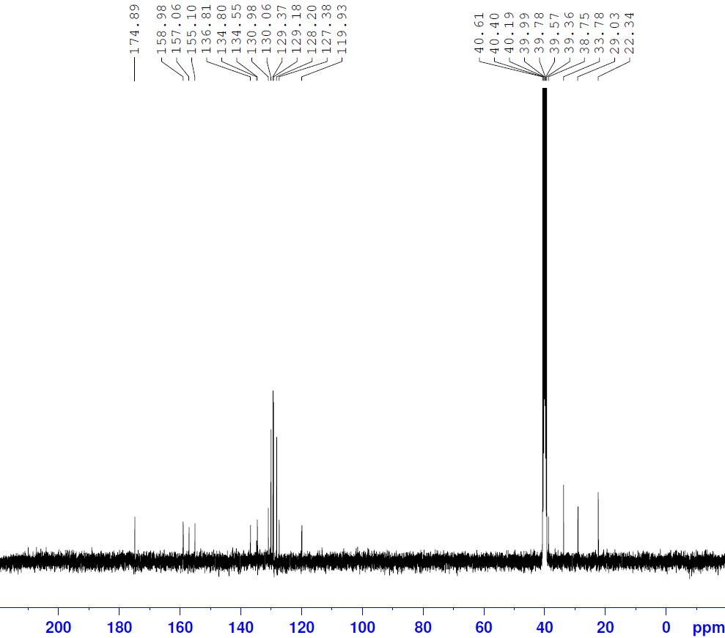
Fig. 33: ¹³C-NMR spectrum of compound 4l (DMSO-d₆)
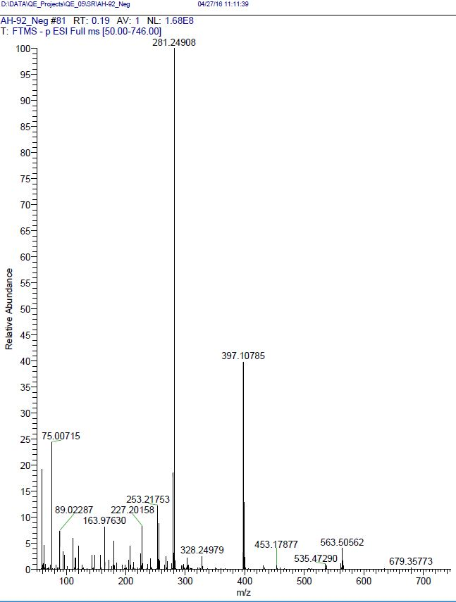
Fig. 34: HRMS of compound 4l

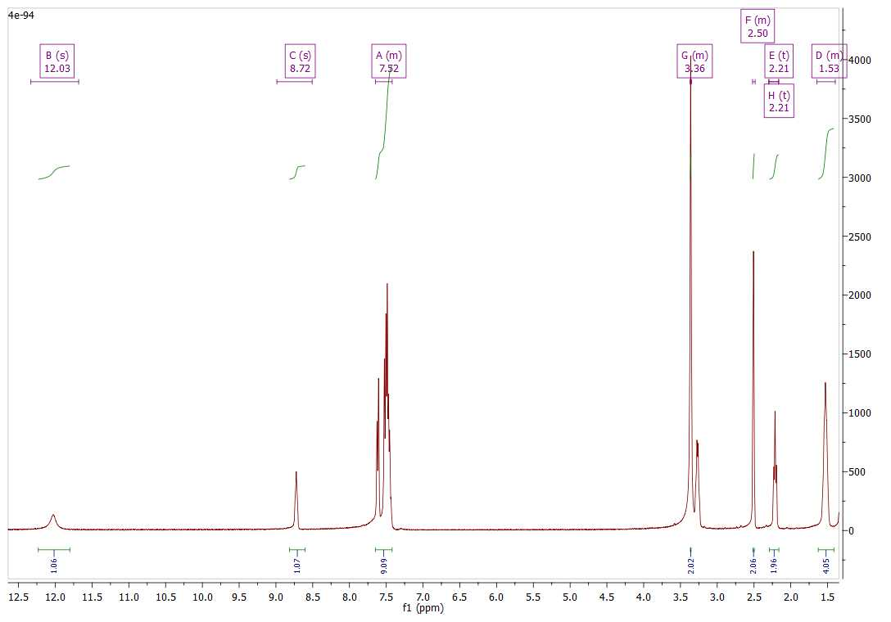
Fig. 35: ¹H-NMR spectrum of compound 4m (CDCl₃)
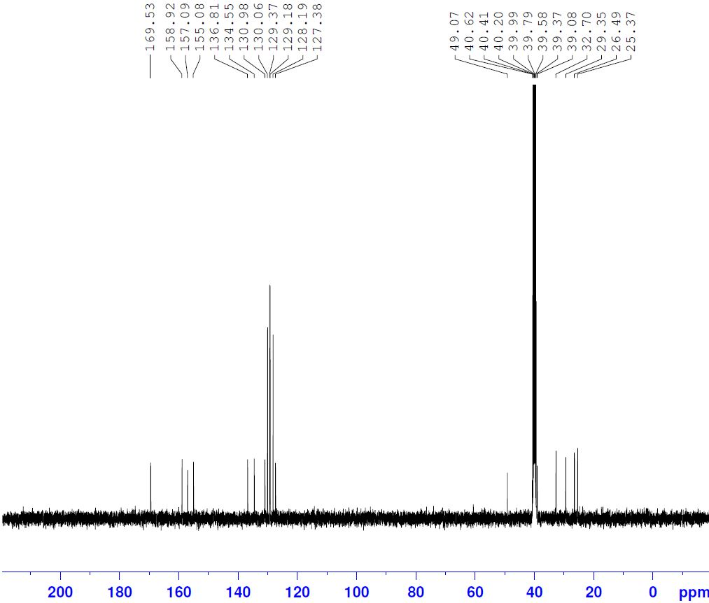
Fig. 36: ¹³C-NMR spectrum of compound 4m (DMSO-d₆)
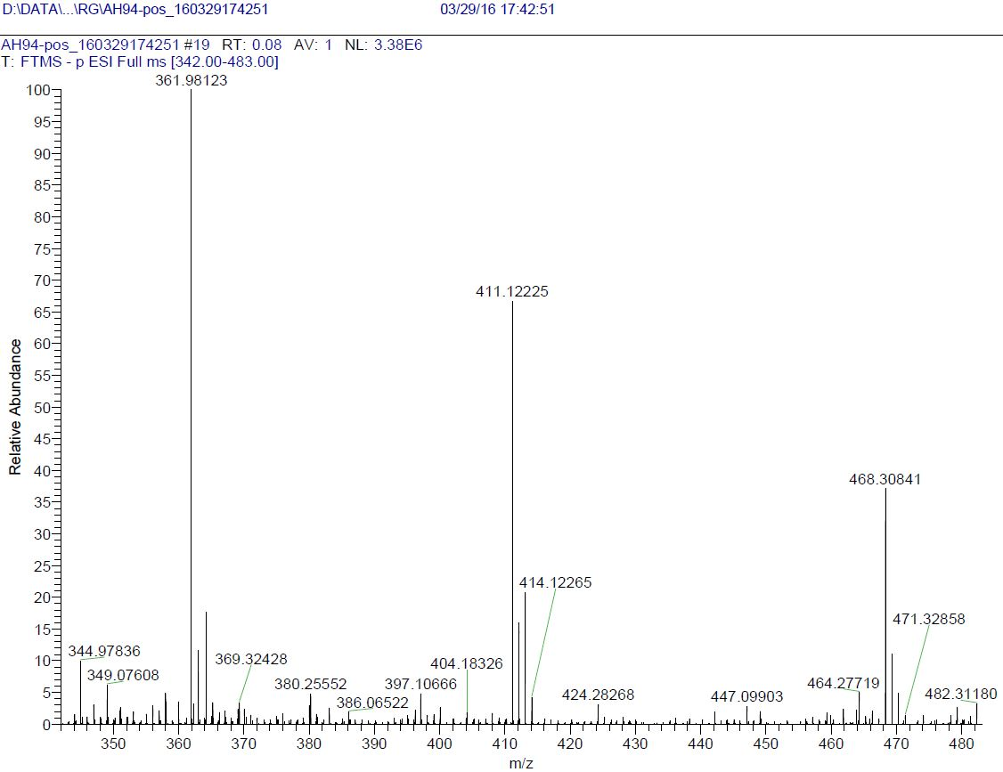
Fig. 37: HRMS of compound 4m

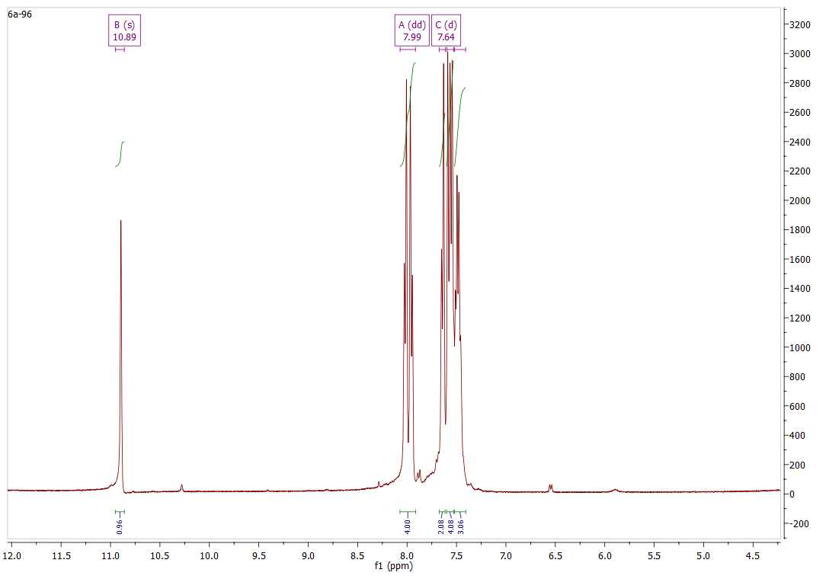
Fig. 38: ¹H-NMR spectrum of compound 4n (CDCl₃)
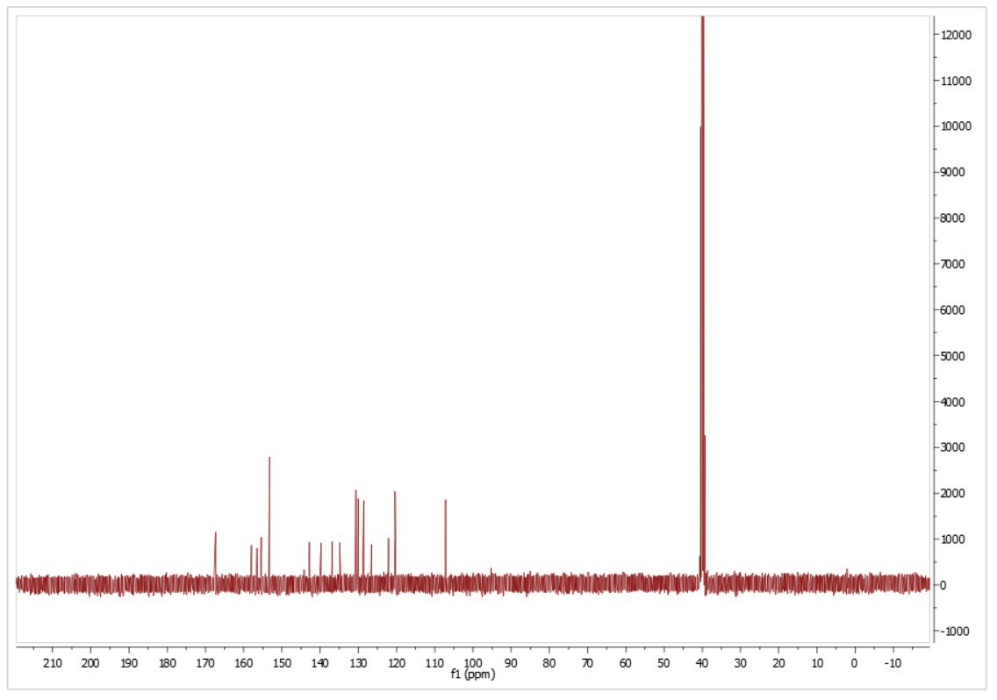
Fig. 39: ¹³C-NMR spectrum of compound 4n (DMSO-d₆)
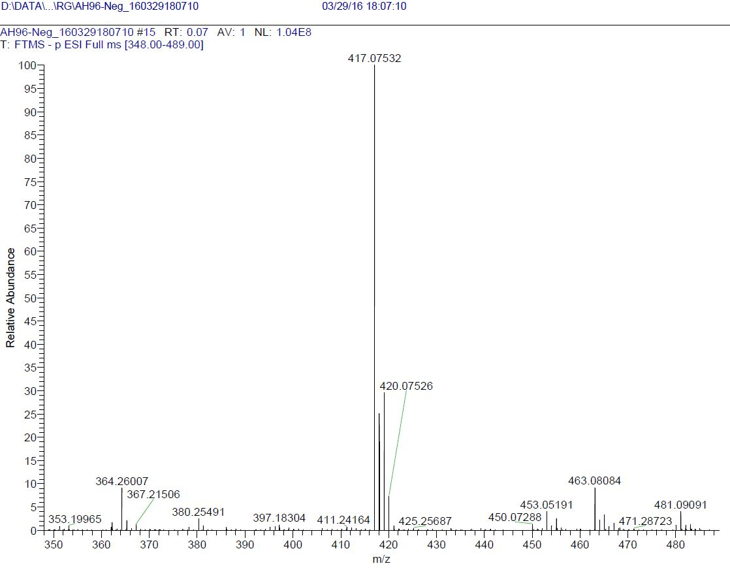
Fig. 40: HRMS of compound 4n

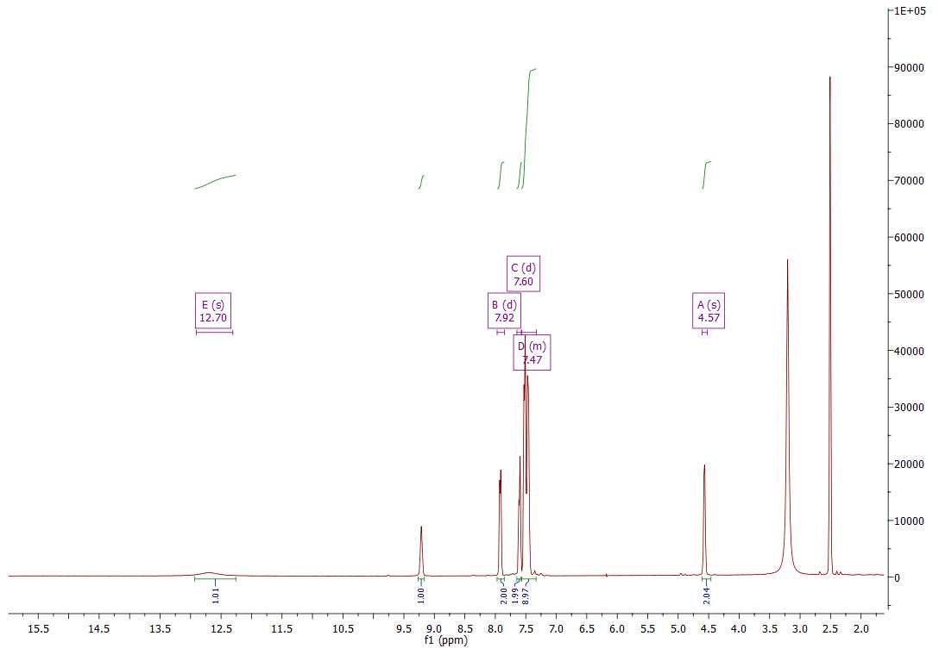
Fig. 41: ¹H-NMR spectrum of compound 4o (DMSO-d₆)
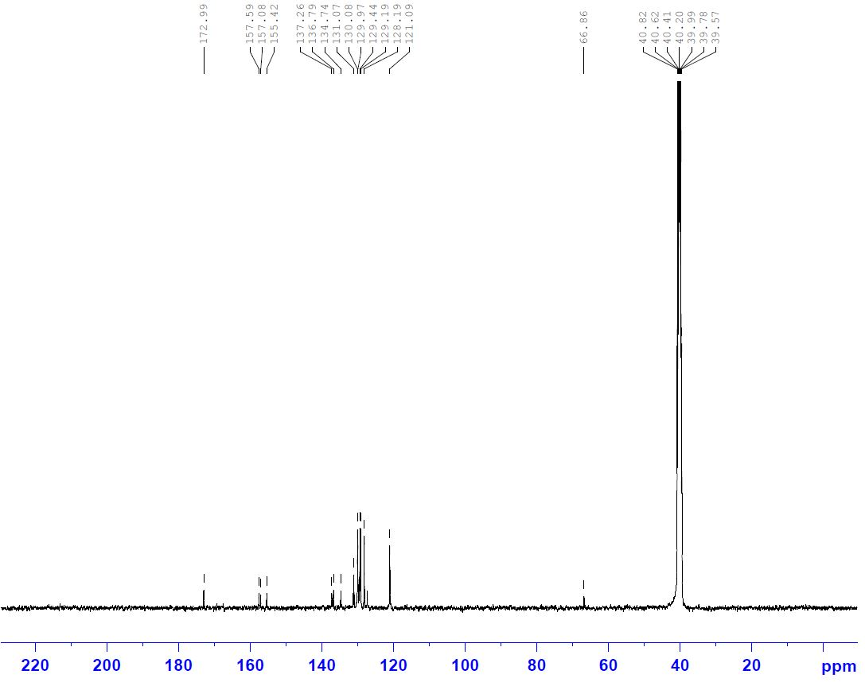
Fig. 42: ¹³C-NMR spectrum of compound 4o (DMSO-d₆)
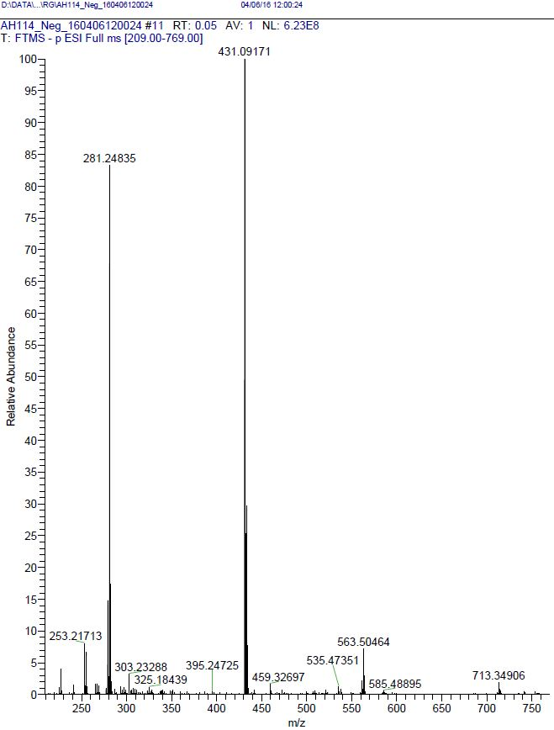
Fig. 43: HRMS of compound 4o
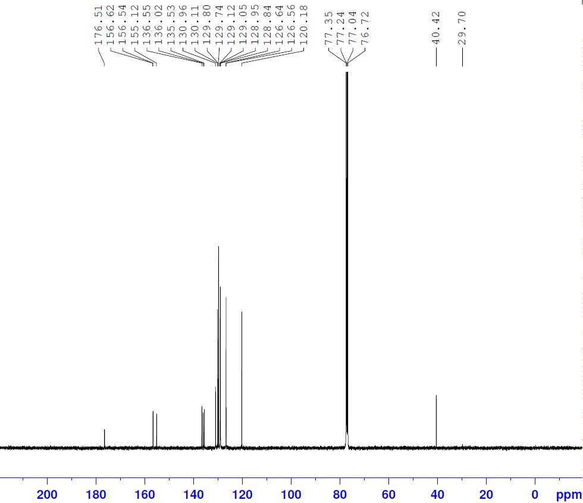
Fig. 44: ¹³C-NMR spectrum of compound 4p (DMSO-d₆)
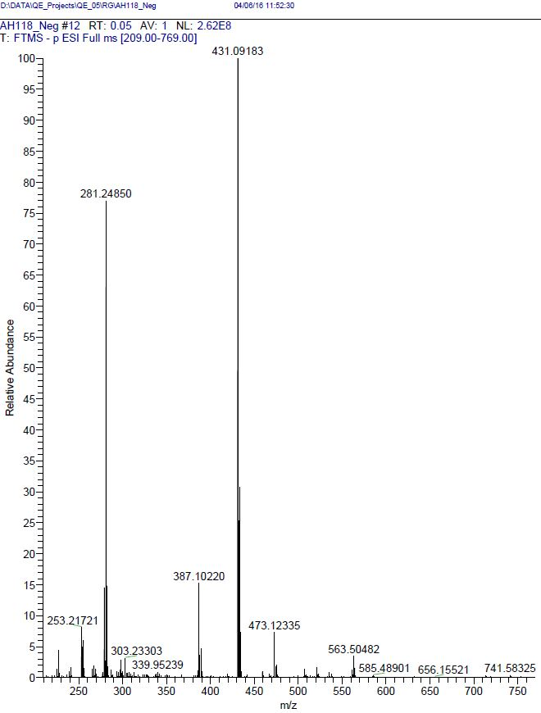
Fig. 45: HRMS of compound 4p

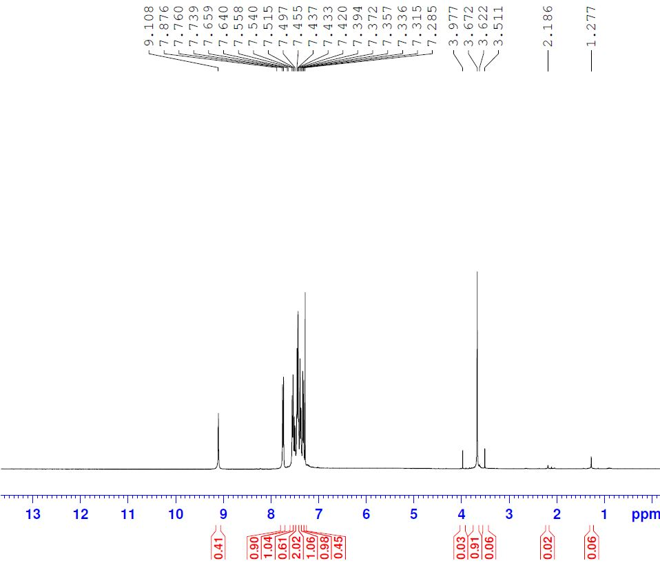
Fig. 46: ¹H-NMR spectrum of compound 4q (CDCl₃)
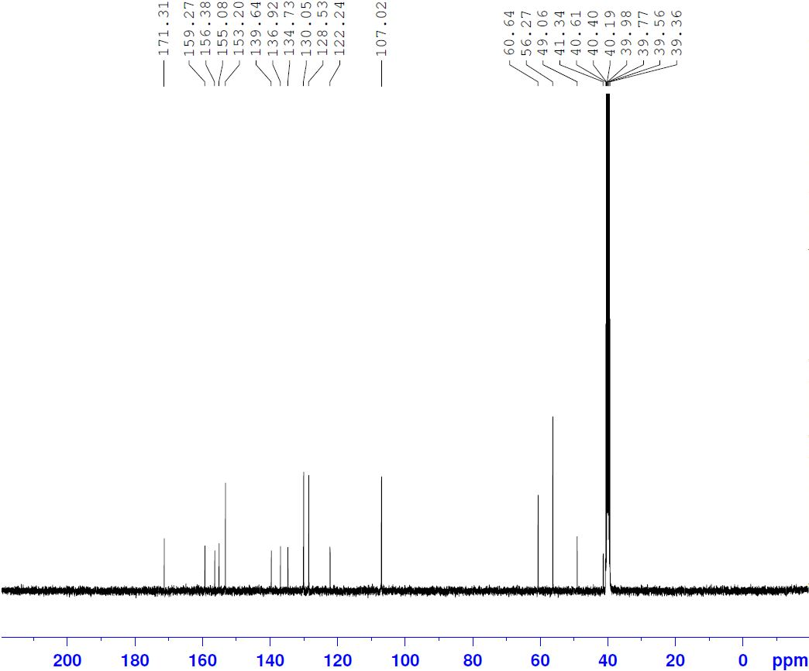
Fig. 47: ¹³C-NMR spectrum of compound 4q (DMSO-d₆)
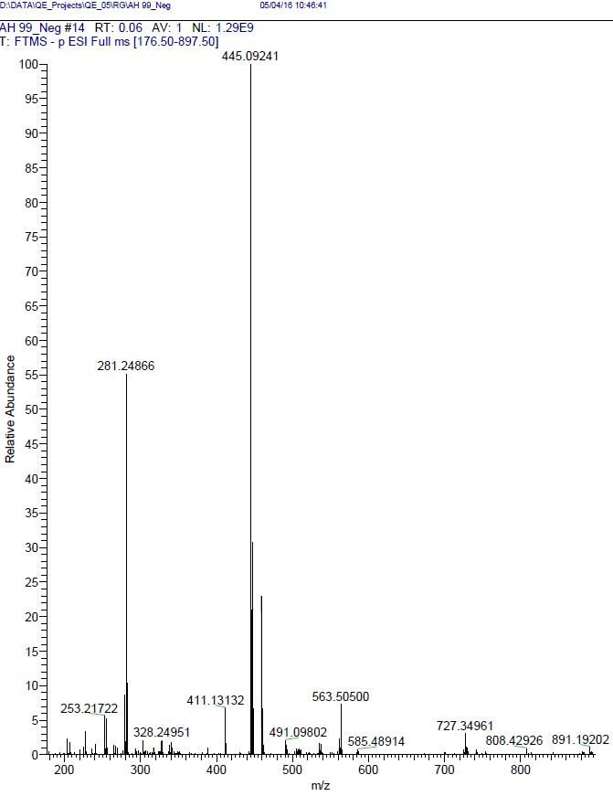
Fig. 48: HRMS of compound 4q

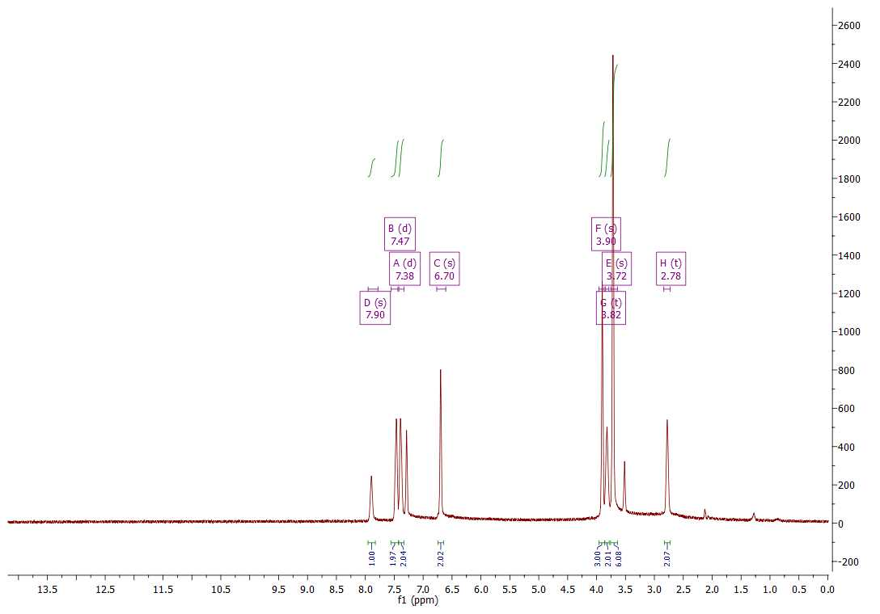
Fig. 49: ¹H-NMR spectrum of compound 4r (CDCl₃)
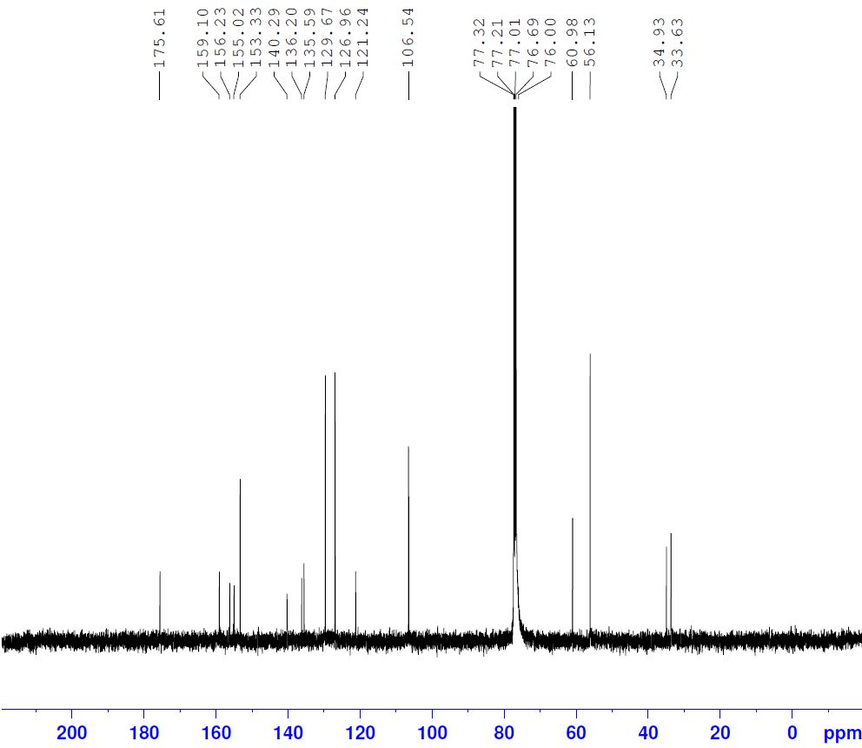
Fig. 50: ¹³C-NMR spectrum of compound 4r (CDCl₃)
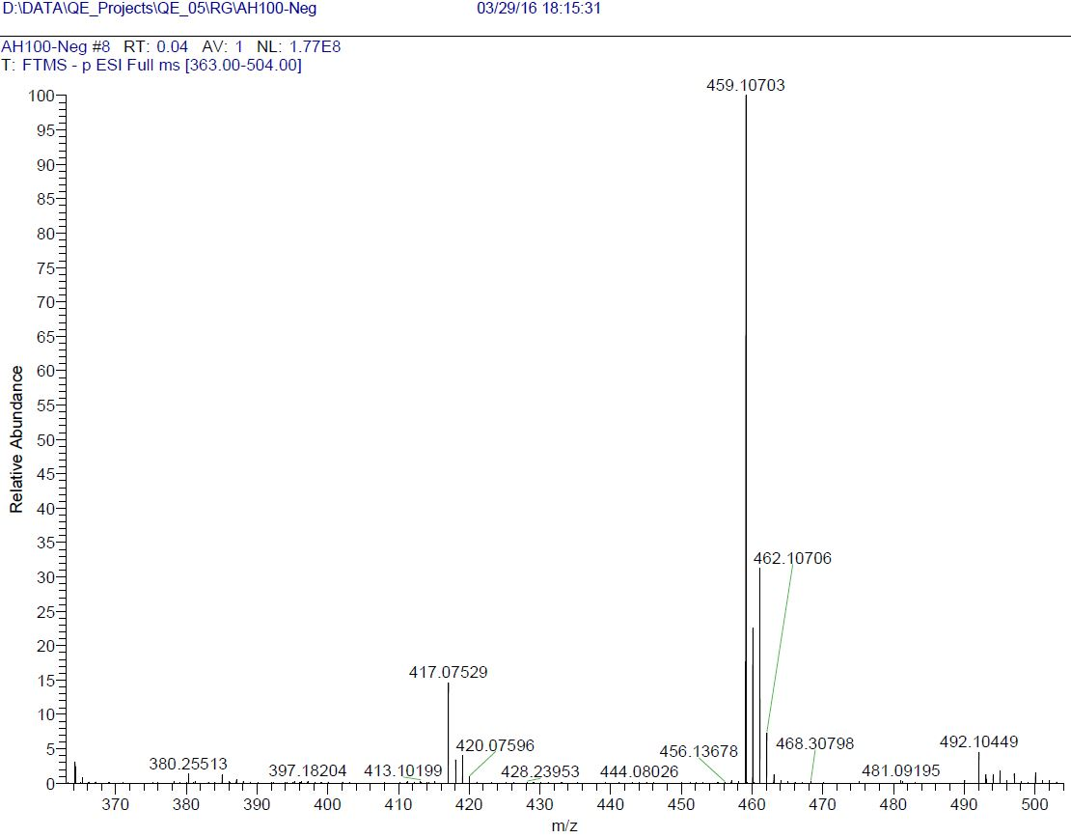
Fig. 51: HRMS of compound 4r

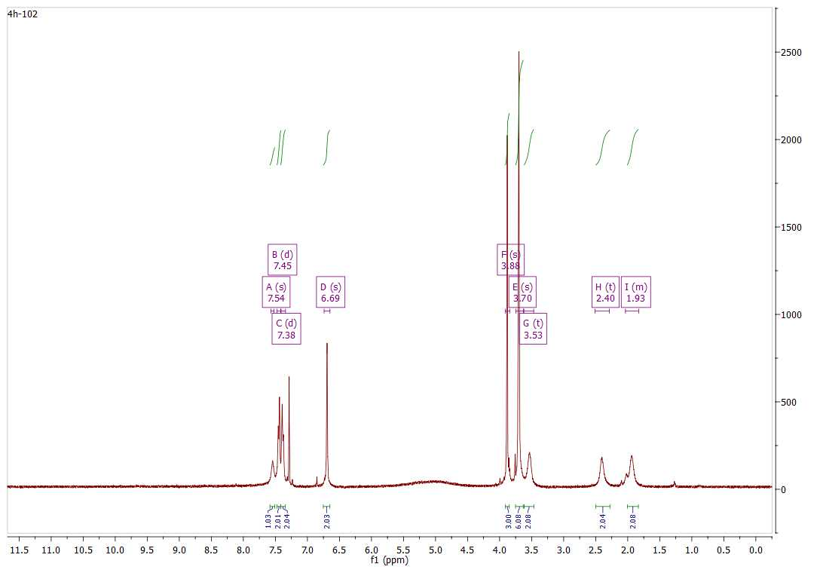
Fig. 52: ¹H-NMR spectrum of compound 4s (CDCl₃)
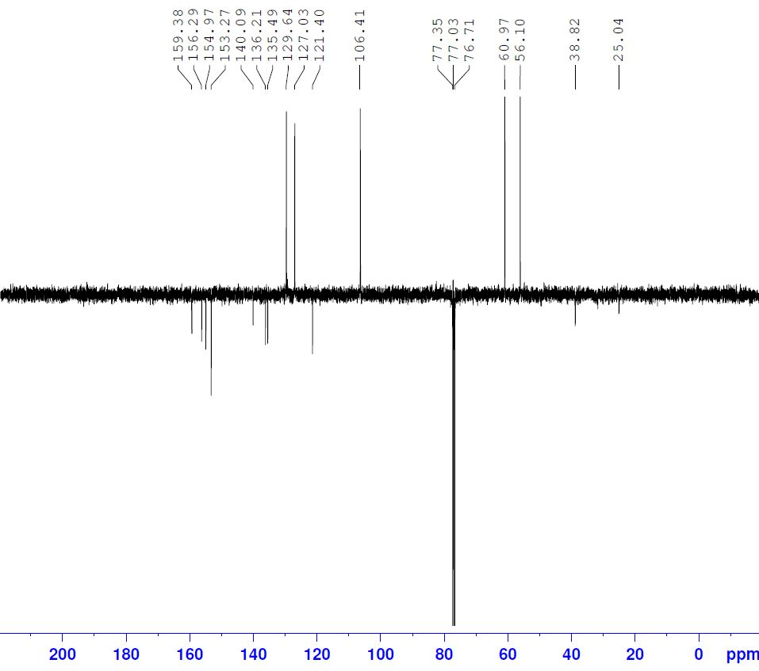
Fig. 53: ¹³C-NMR spectrum of compound 4s (CDCl₃)
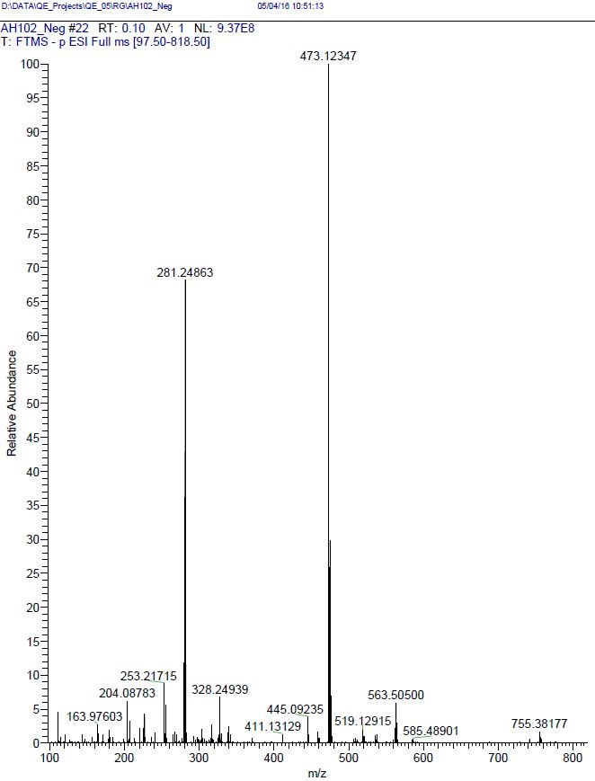
Fig. 54: HRMS of compound 4s

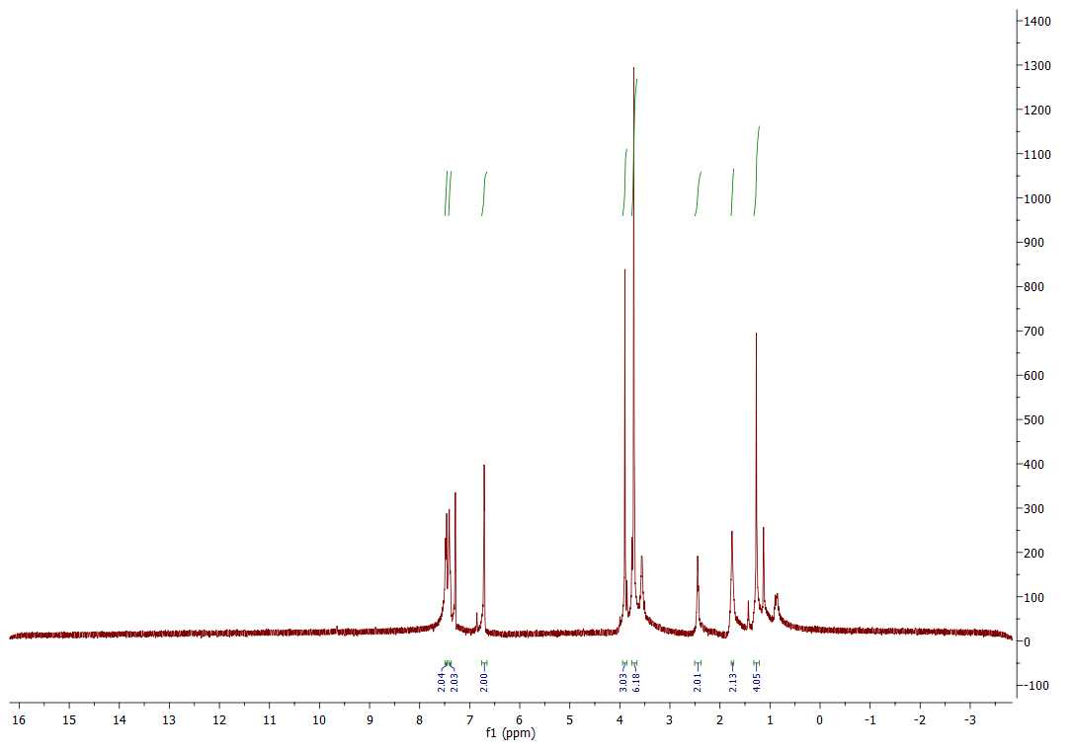
Fig. 55: ¹H-NMR spectrum of compound 4t (CDCl₃)
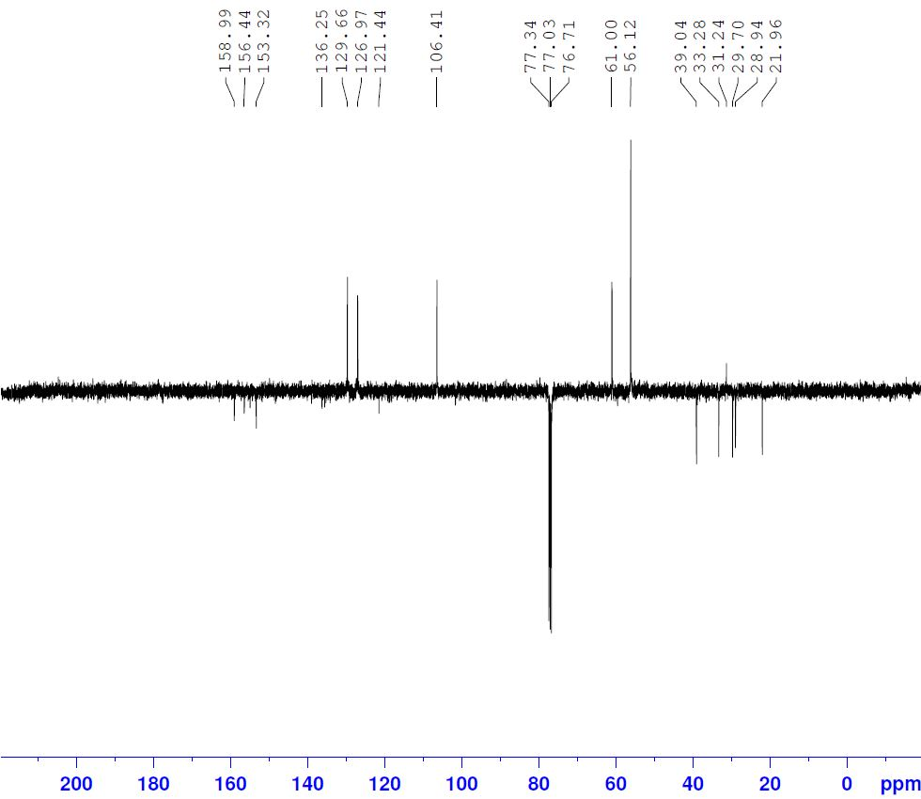
Fig. 56: ¹³C-NMR spectrum of compound 4t (CDCl₃)
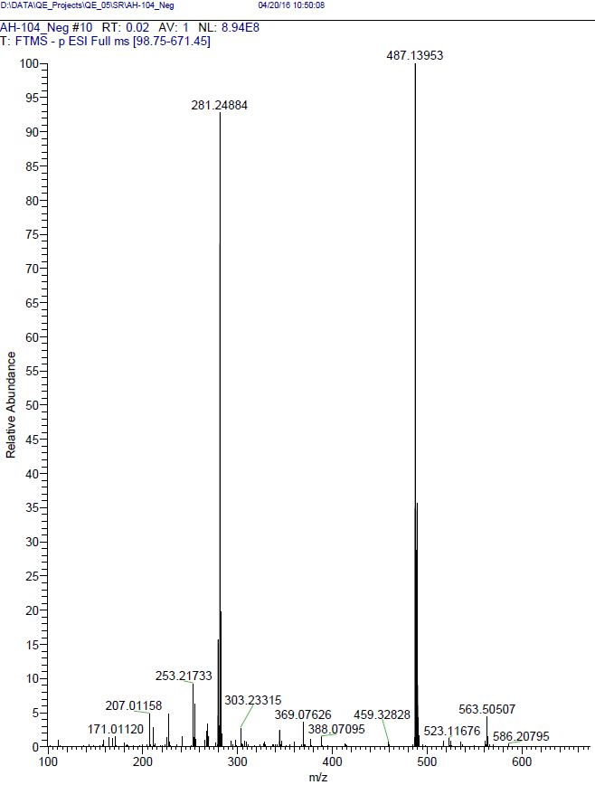
Fig. 57: HRMS of compound 4t

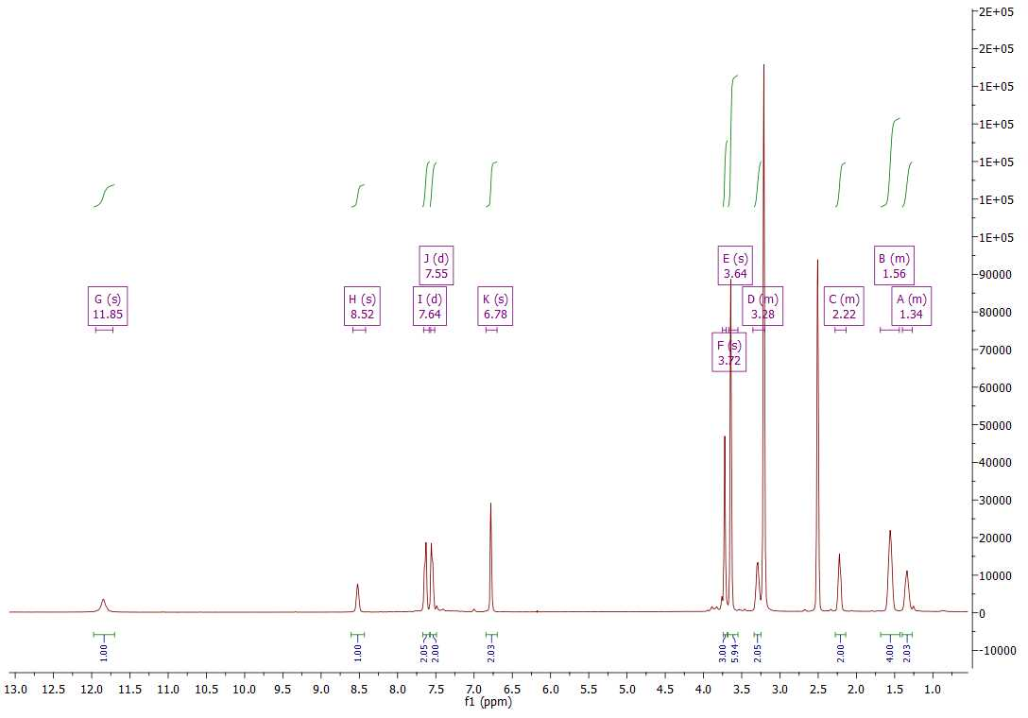
Fig. 58: ¹H-NMR spectrum of compound 4u (DMSO-d₆)
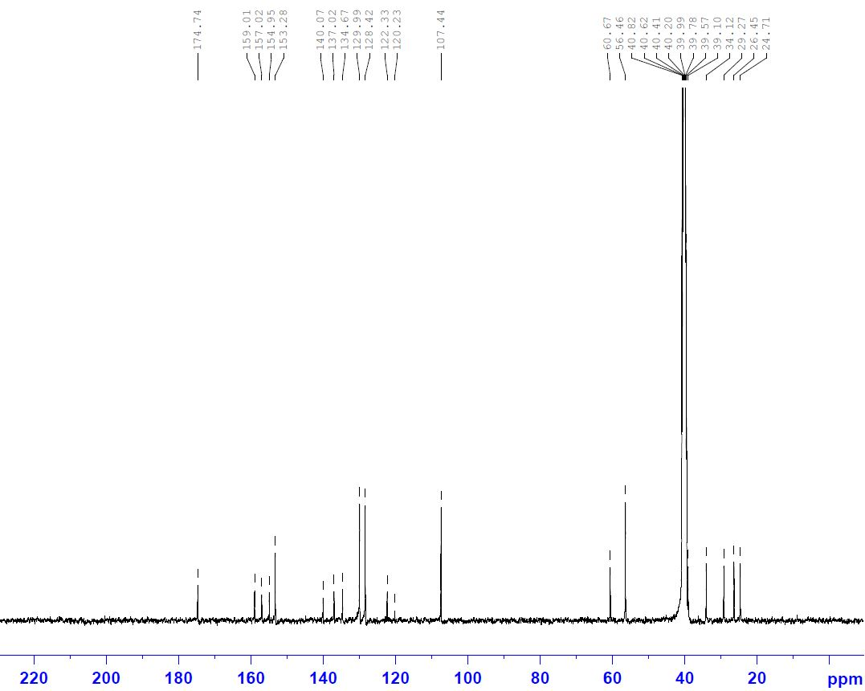
Fig. 59: ¹³C-NMR spectrum of compound 4u (CDCl₃)
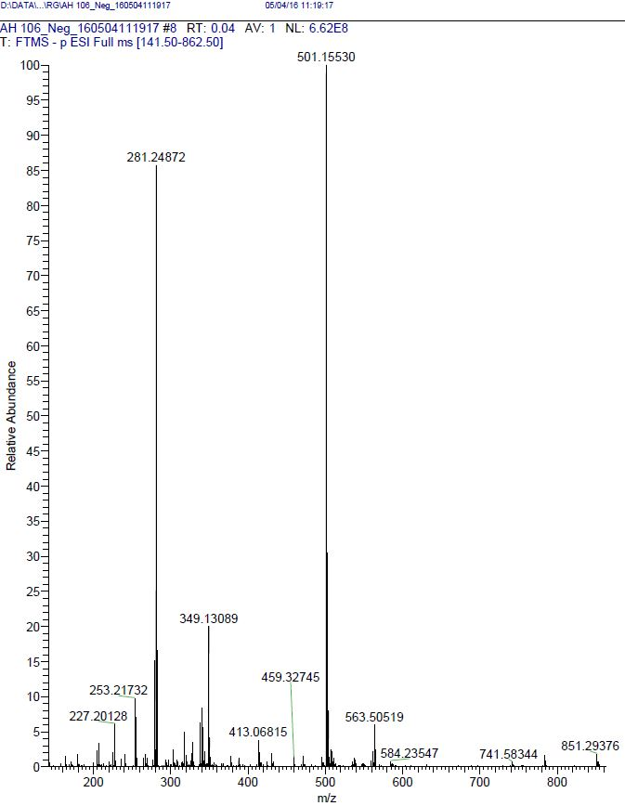
Fig. 60: HRMS of compound 4u

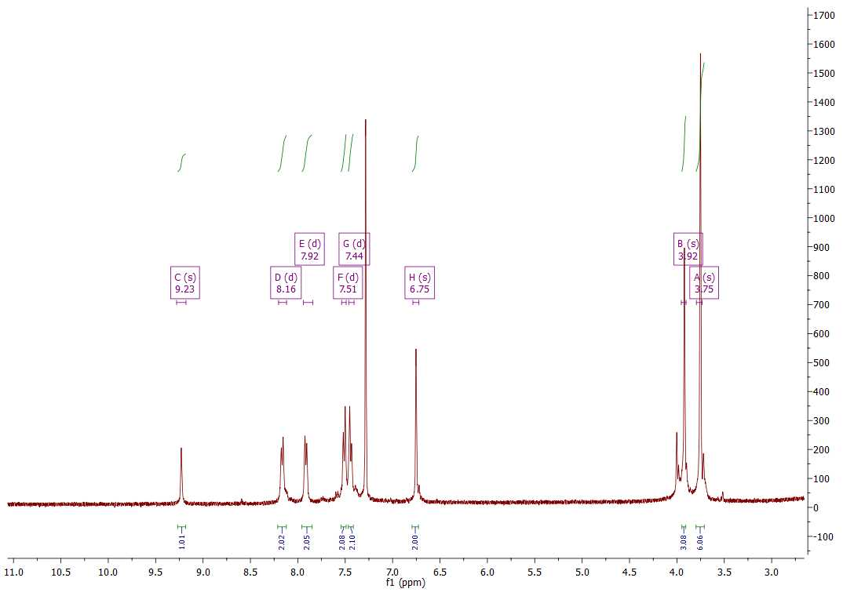
Fig. 61: ¹H-NMR spectrum of compound 4v (CDCl₃)
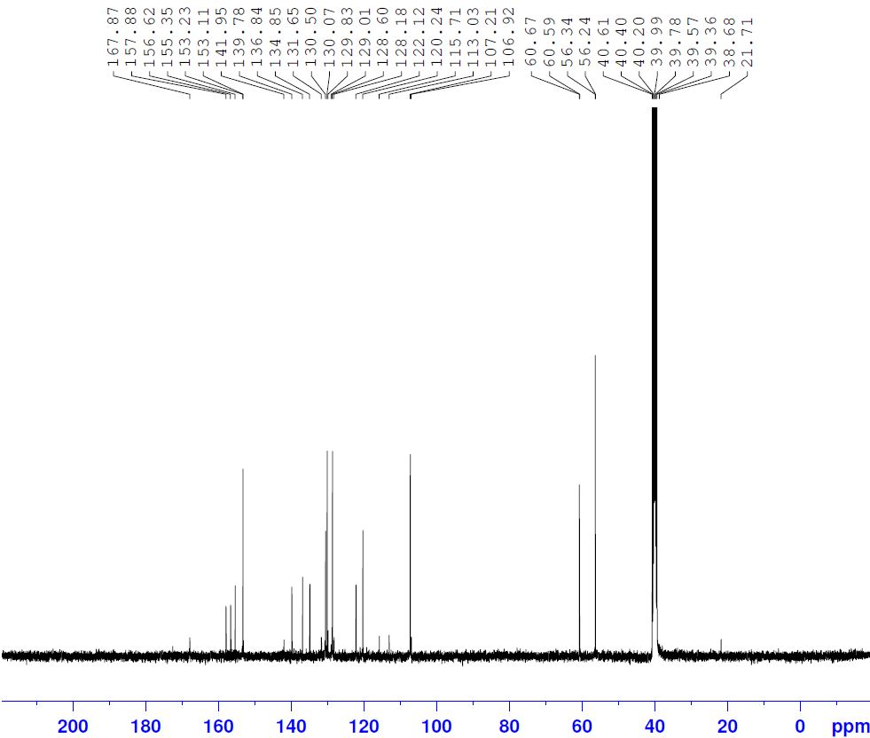
Fig. 62: ¹³C-NMR spectrum of compound 4v (DMSO-d₆)
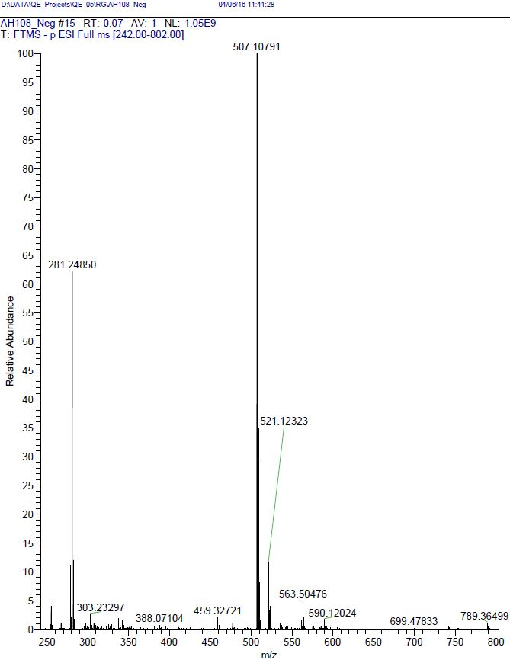
Fig. 63: HRMS of compound 4v

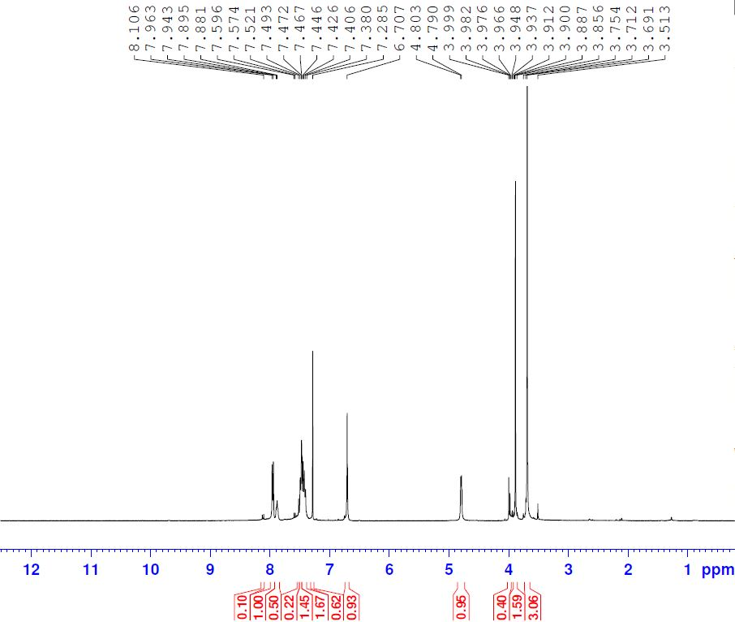
Fig. 64: ¹H-NMR spectrum of compound 4w (CDCl₃)
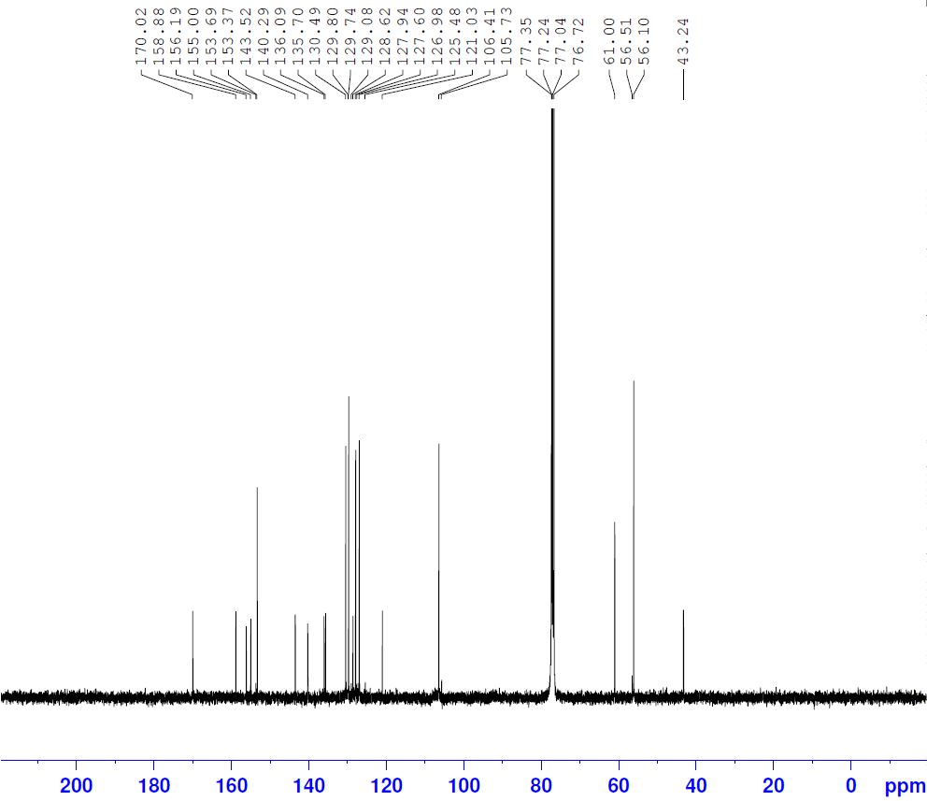
Fig. 65: ¹³C-NMR spectrum of compound 4w (CDCl₃)
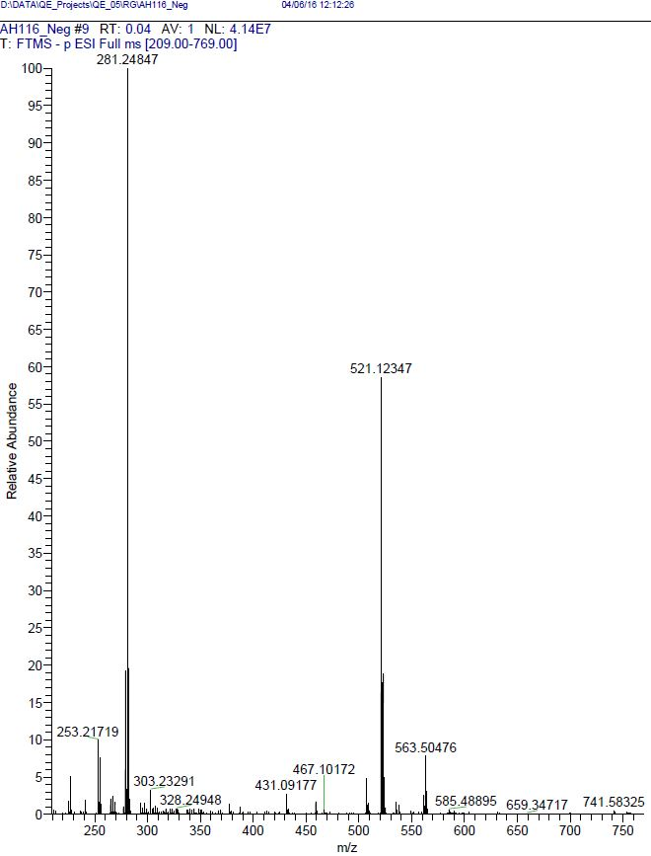
Fig. 66: HRMS of compound 4w

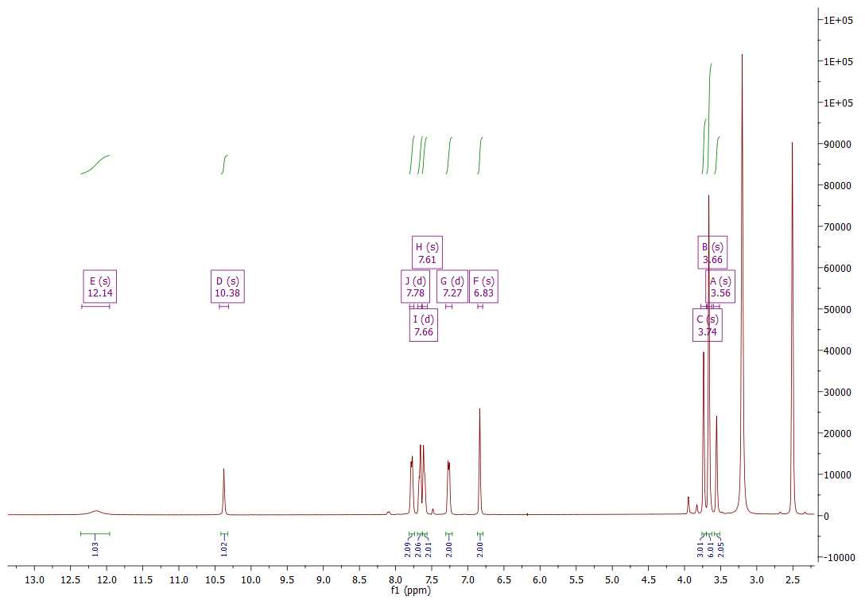
Fig. 67: ¹H-NMR spectrum of compound 4x (DMSO-d₆)
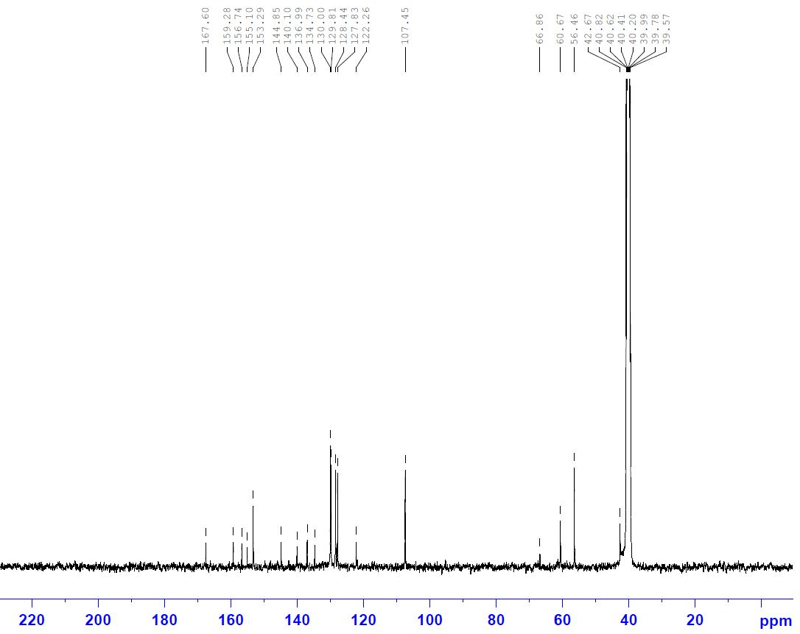
Fig. 68: ¹³C-NMR spectrum of compound 4x (DMSO-d₆)
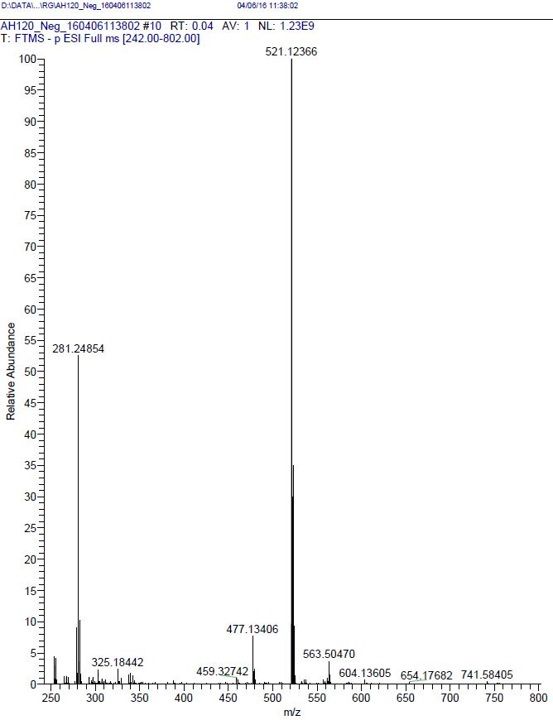
Fig. 69: HRMS of compound 4x

- Fig 70:¹H-NMR spectrum of compound 5a (CDCl₃)
- Fig. 71: ¹H-NMR spectrum of compound 5b (DMSO-d₆)

- Fig. 72: ¹H NMR spectrum of compound 5c (DMSO-d₆)

- Fig. 73: ¹H-NMR spectrum of compound 5d (DMSO-d₆)

- Fig. 74: ¹H-NMR spectrum of compound 5e (DMSO-d₆)

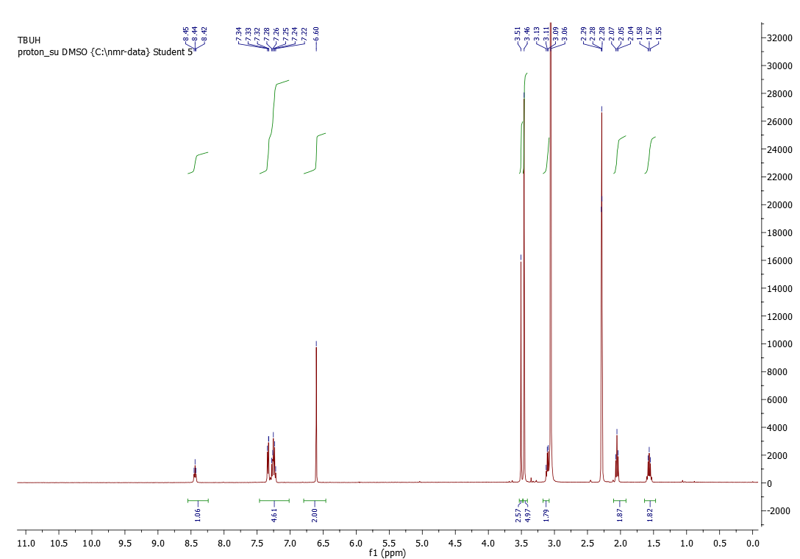
Fig. 75: ¹H-NMR spectrum of compound 5f (DMSO-d₆)

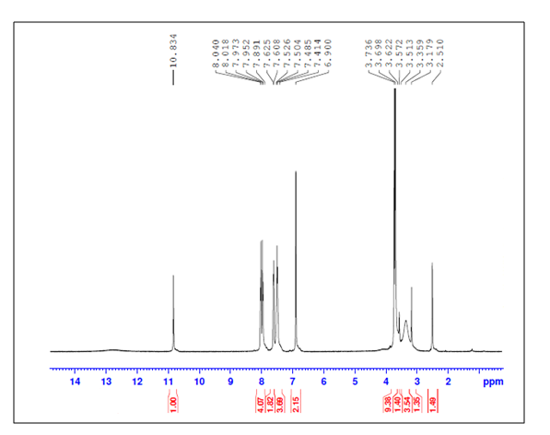
Fig. 76: ¹H-NMR spectrum of compound 5g (DMSO-d₆)

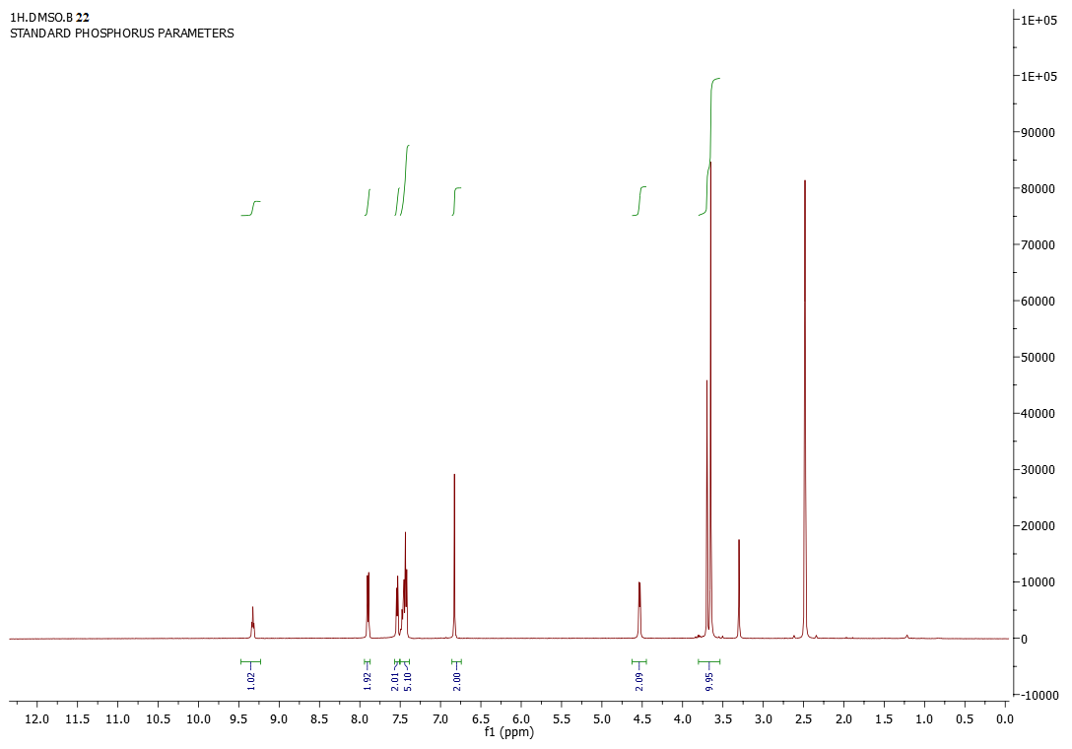
Fig. 77: ¹H-NMR spectrum of compound 5h (DMSO-d₆)

Fig. 78: ¹H-NMR spectrum of compound 5i (CDCl₃)
Fig. 79: ¹³C-NMR spectrum of compound 5i (CDCl₃)

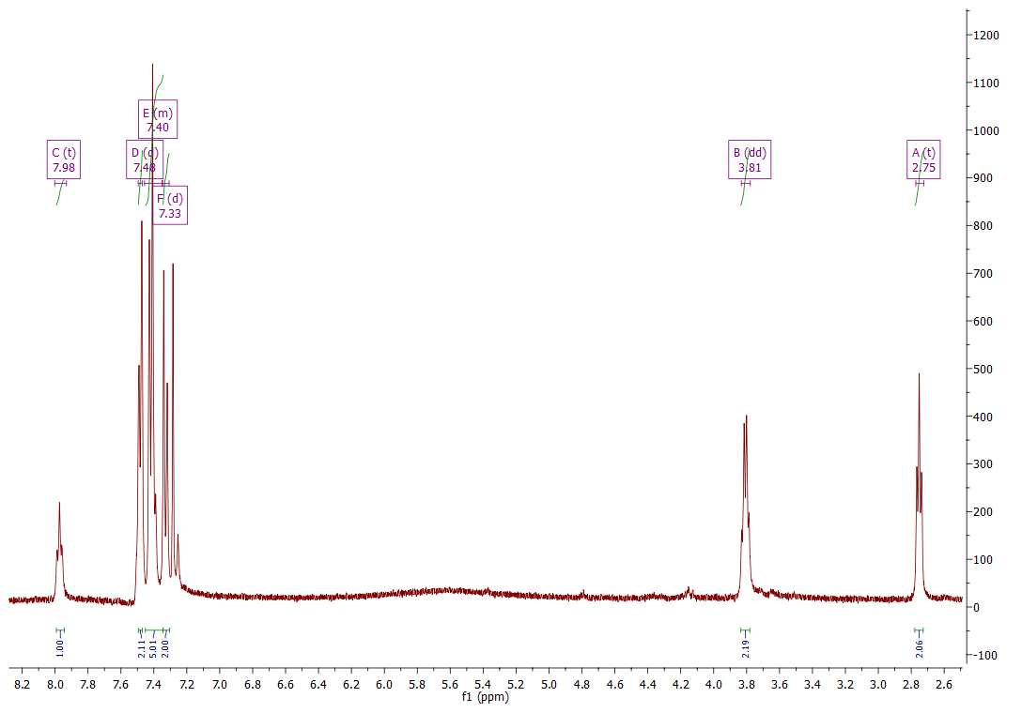
Fig. 80: ¹H-NMR spectrum of compound 5j (CDCl₃)
Fig. 81: ¹³C-NMR spectrum of compound 5j (CDCl₃)

Fig. 82: ¹H-NMR spectrum of compound 5k (CDCl₃)
Fig. 83: ¹³C-NMR spectrum of compound 5k (CDCl₃)

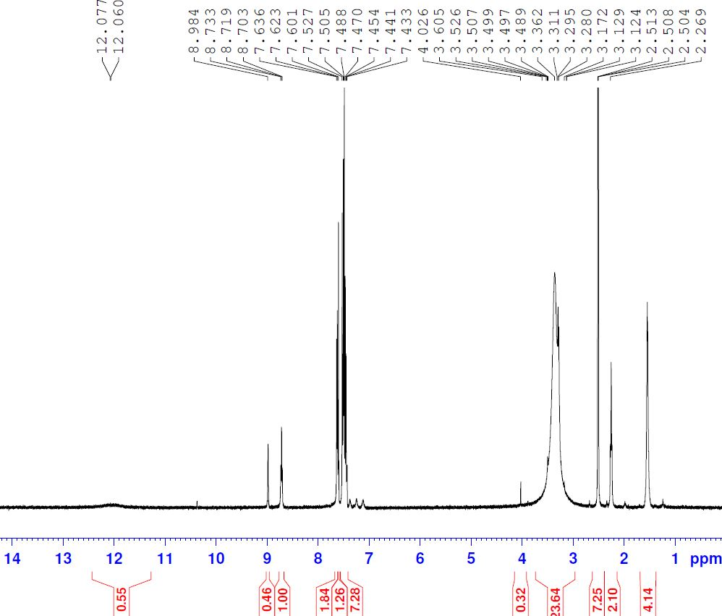
Fig. 84: ¹H-NMR spectrum of compound 5l (DMSO-d₆)
Fig. 85: ¹³C-NMR spectrum of compound 5l (DMSO-d₆)

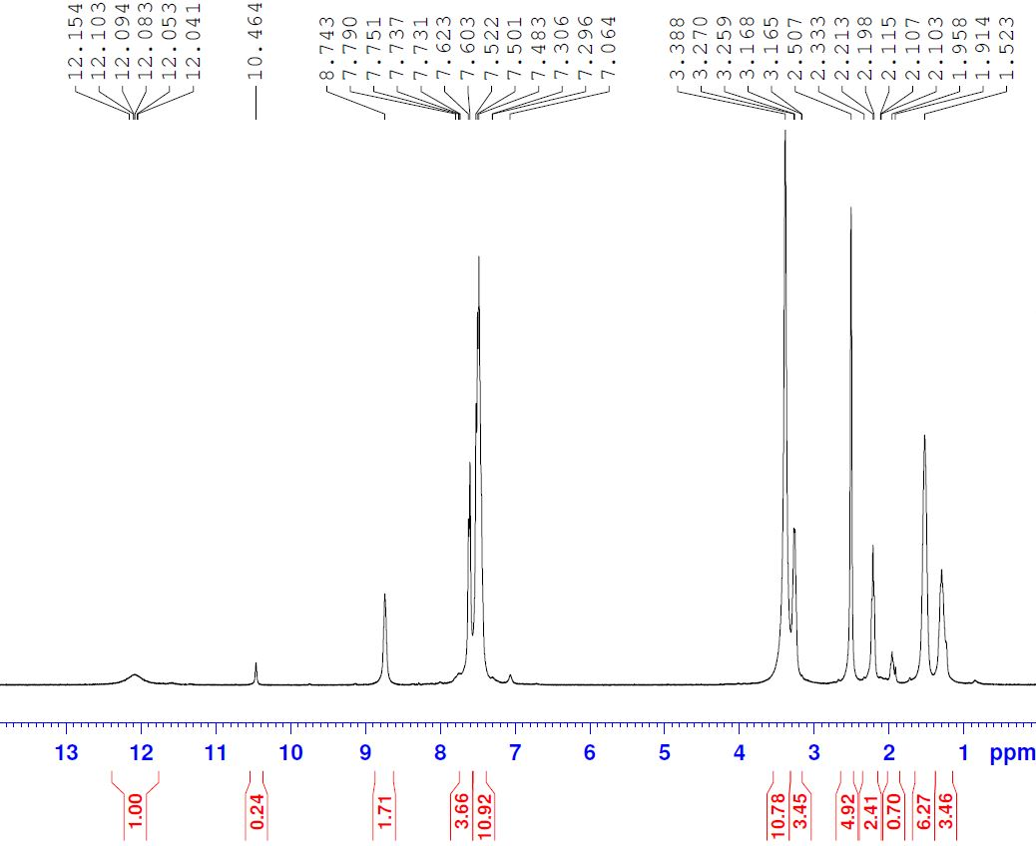
Fig. 86: ¹H-NMR spectrum of compound 5m (DMSO-d₆)
Fig. 87: ¹³C-NMR spectrum of compound 5m (DMSO-d₆)

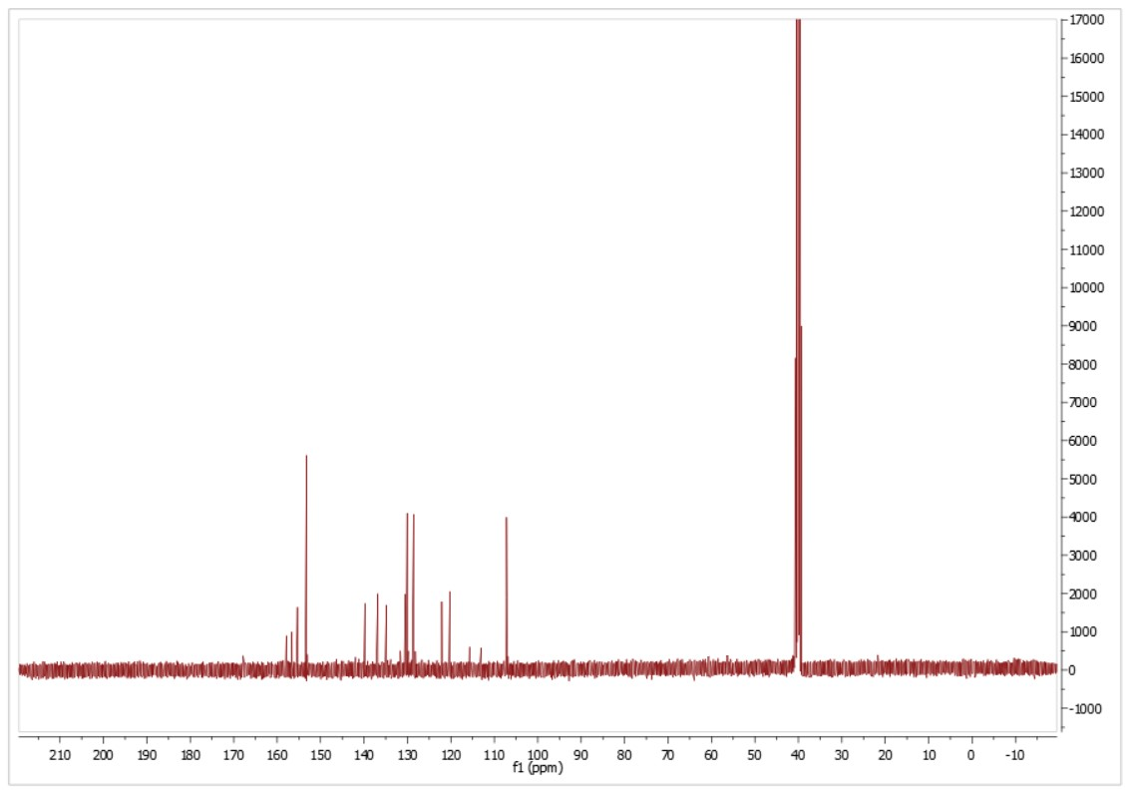
Fig. 88: ¹³C-NMR spectrum of compound 5n (DMSO-d₆)

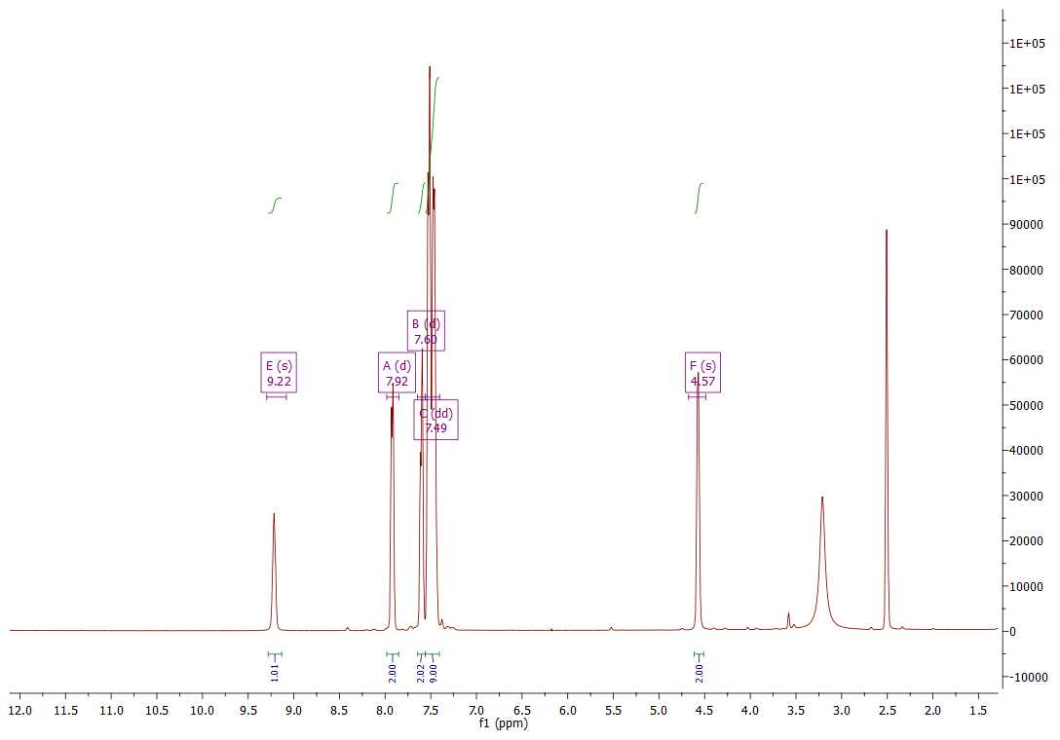
Fig. 89: ¹H-NMR spectrum of compound 5o (DMSO-d₆)
Fig. 90: ¹³C-NMR spectrum of compound 5o (CDCl₃)

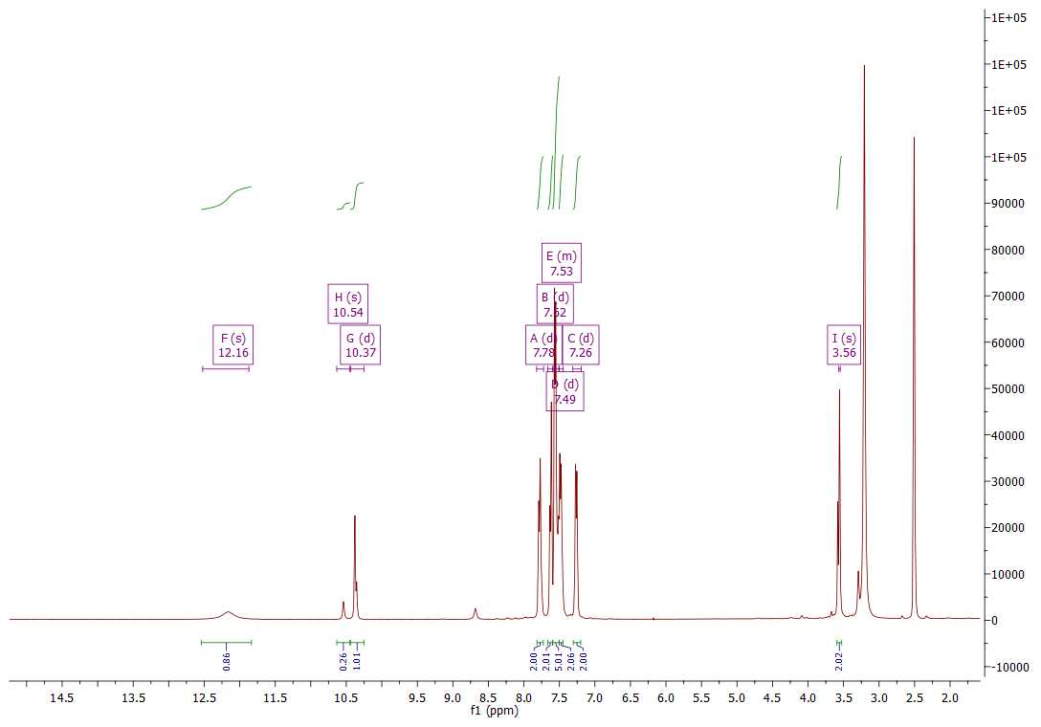
Fig. 91: ¹H-NMR spectrum of compound 5p (DMSO-d₆)
Fig. 92: ¹³C-NMR spectrum of compound 5p (DMSO-d₆)

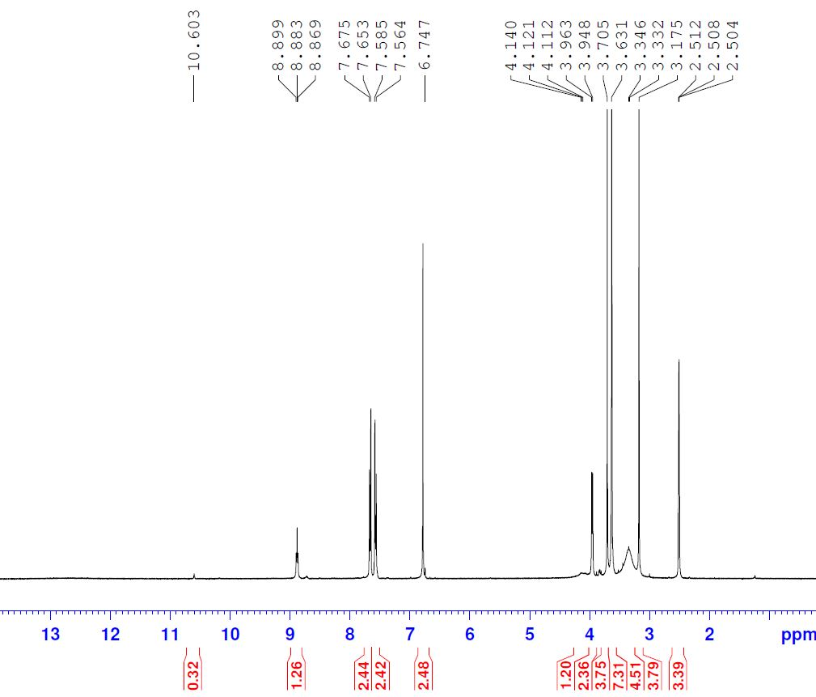
Fig. 93: ¹H-NMR spectrum of compound 5q (DMSO-d₆)
Fig. 94: ¹³C-NMR spectrum of compound 5q (DMSO-d₆)

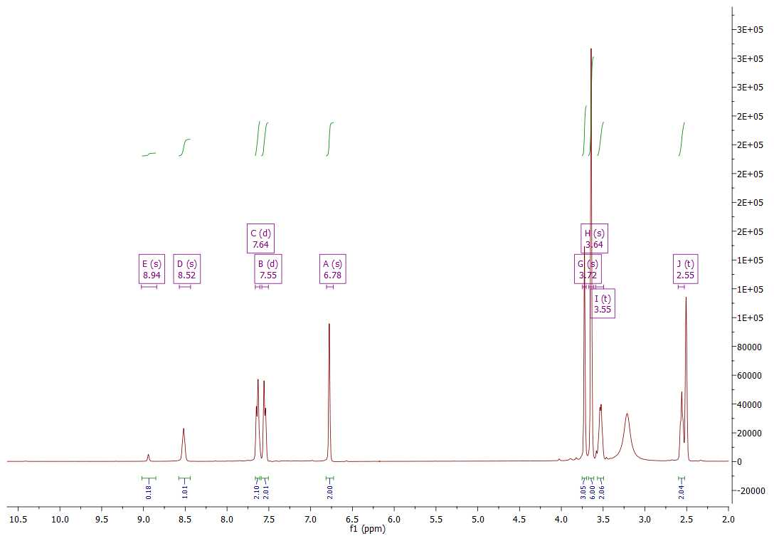
Fig. 95: ¹H-NMR spectrum of compound 5r (DMSO-d₆)
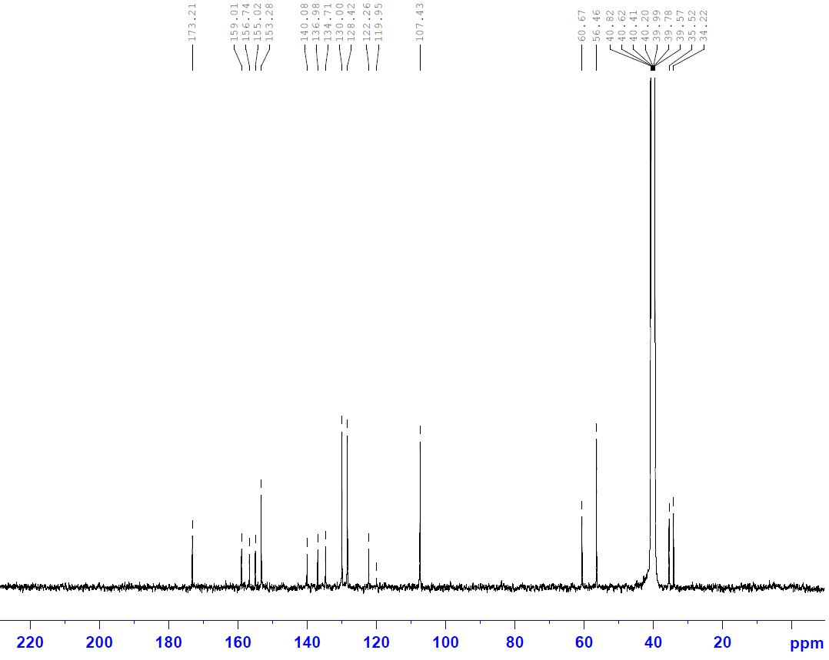
Fig. 96: ¹³C-NMR spectrum of compound 5r (DMSO-d₆)

Fig. 97: ¹H-NMR spectrum of compound 5s (CDCl₃)
Fig. 98: ¹³C-NMR spectrum of compound 5s (CDCl₃)

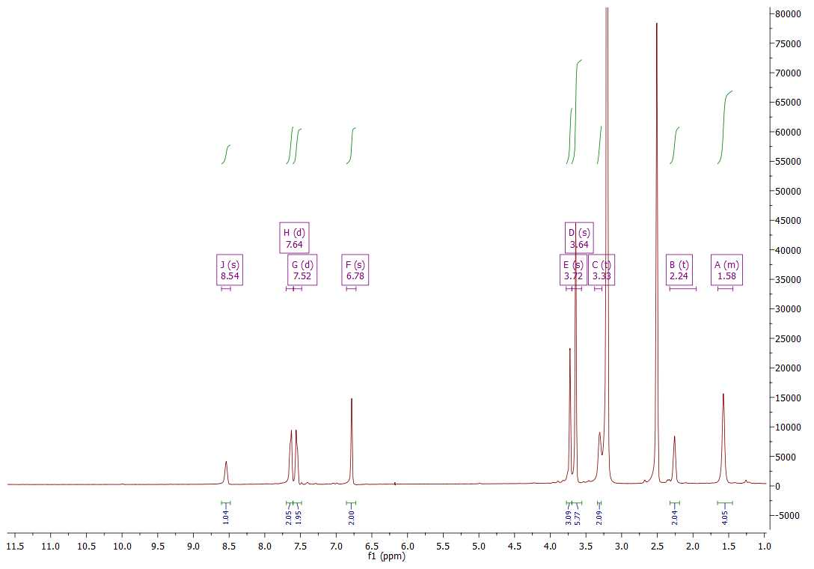
Fig. 99: ¹H-NMR spectrum of compound 5t (DMSO-d₆)
Fig. 100: ¹³C-NMR spectrum of compound 5t (CDCl₃)

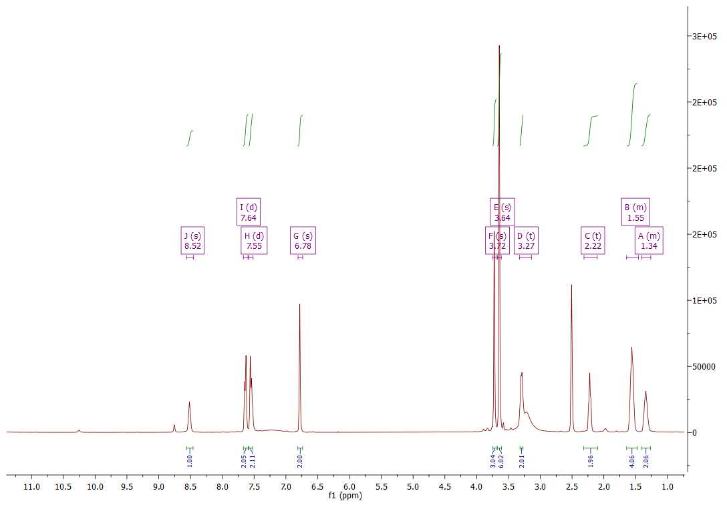
Fig. 101: ¹H-NMR spectrum of compound 5u (DMSO-d₆)
Fig. 102: ¹³C-NMR spectrum of compound 5u (DMSO-d₆)

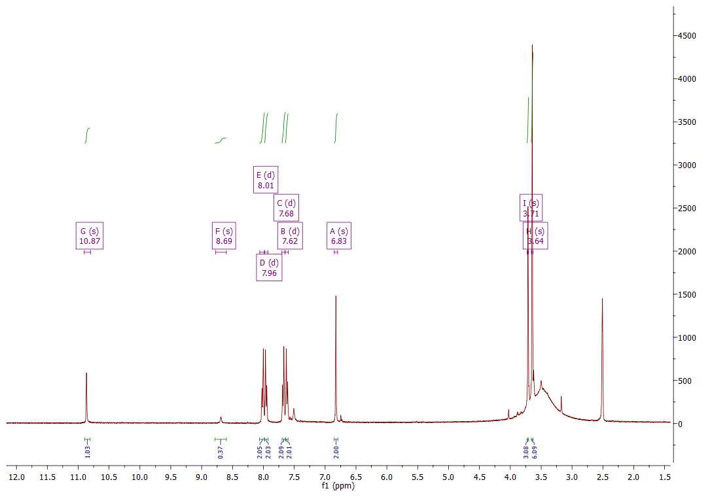
Fig. 103: ¹H-NMR spectrum of compound 5v (DMSO-d₆)
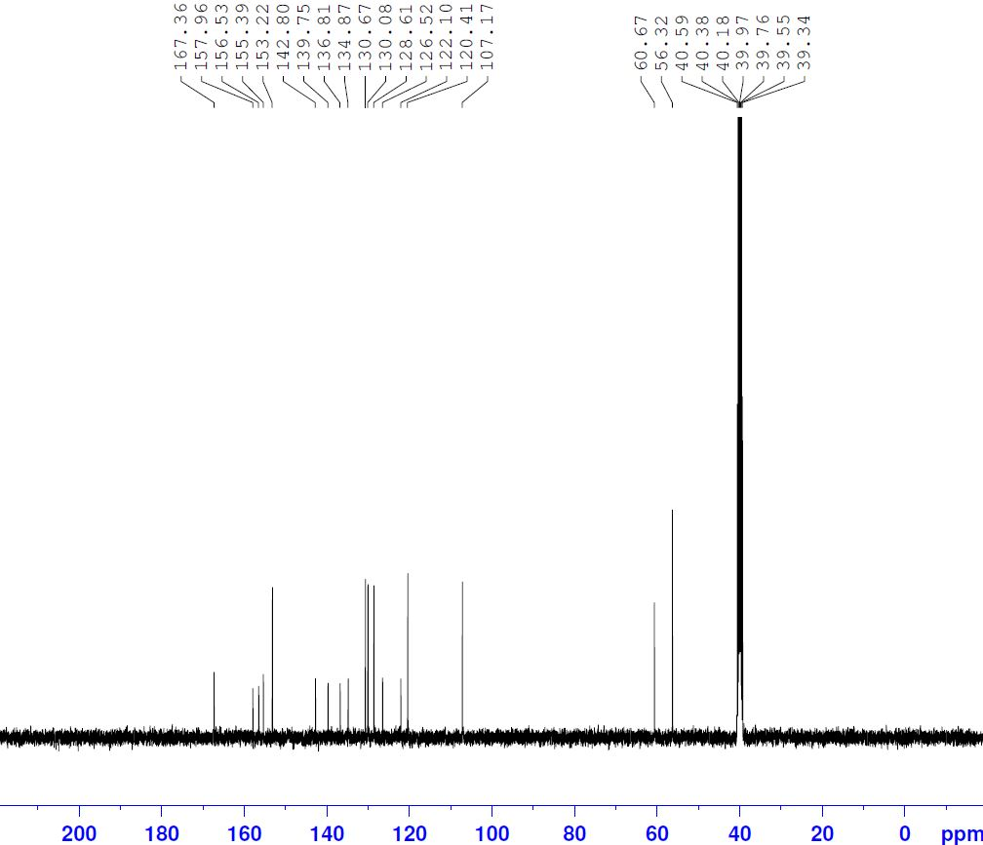
Fig. 104: ¹³C-NMR spectrum of compound 5v (DMSO-d₆)

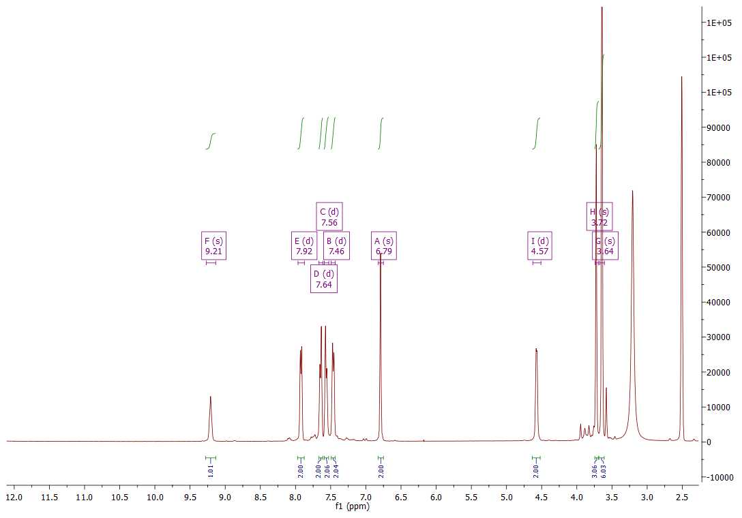
Fig. 105: ¹H-NMR spectrum of compound 5w (DMSO-d₆)
Fig. 106: ¹³C-NMR spectrum of compound 5w (DMSO-d₆)

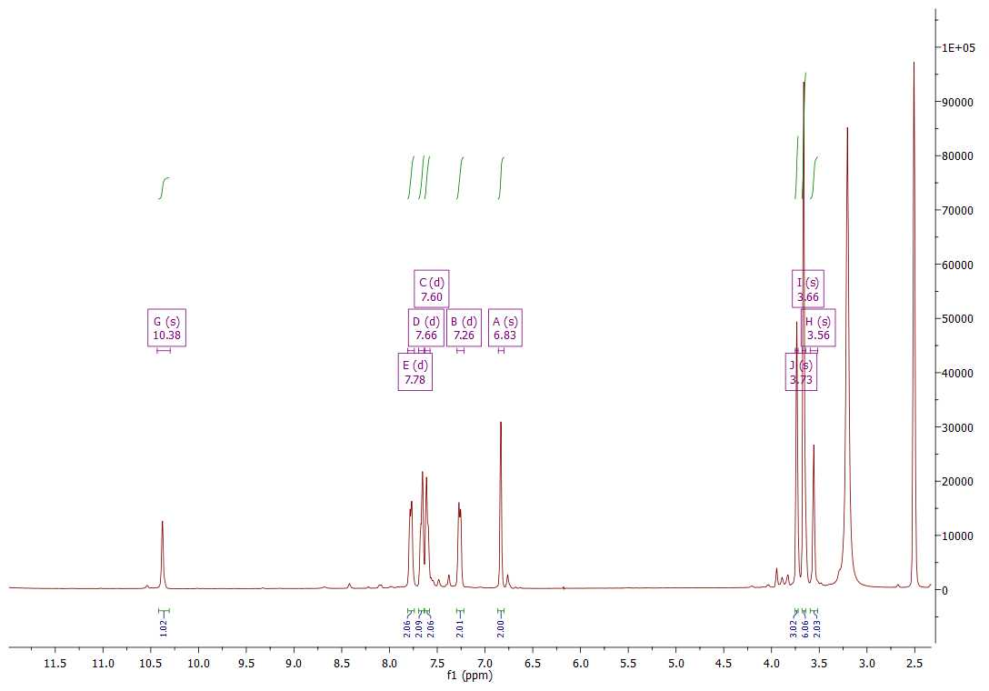
Fig. 107: ¹H-NMR spectrum of compound 5x (DMSO-d₆)
Fig. 108: ¹³C-NMR spectrum of compound 5x (CDCl₃)

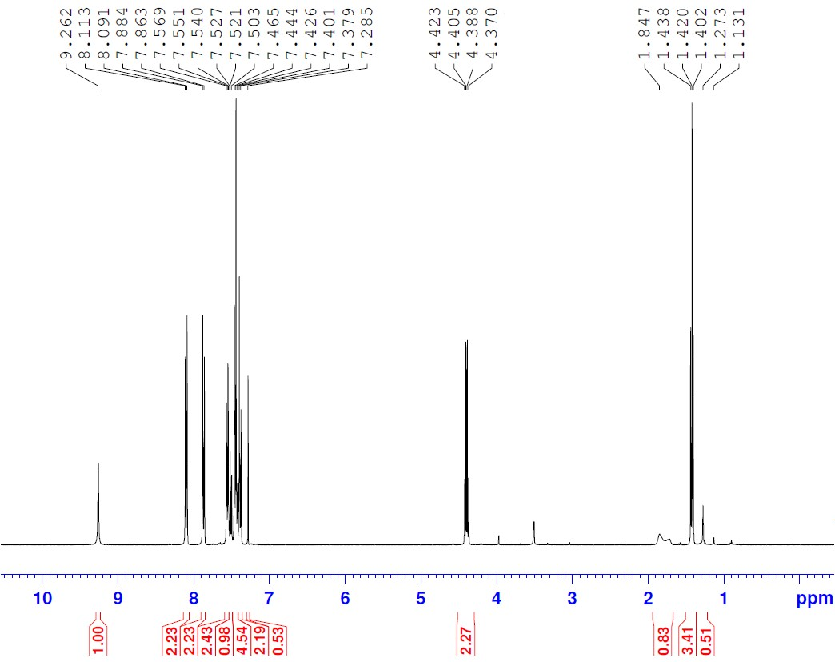

Fig. 109: ¹H-NMR spectrum of compound 6a (CDCl₃)
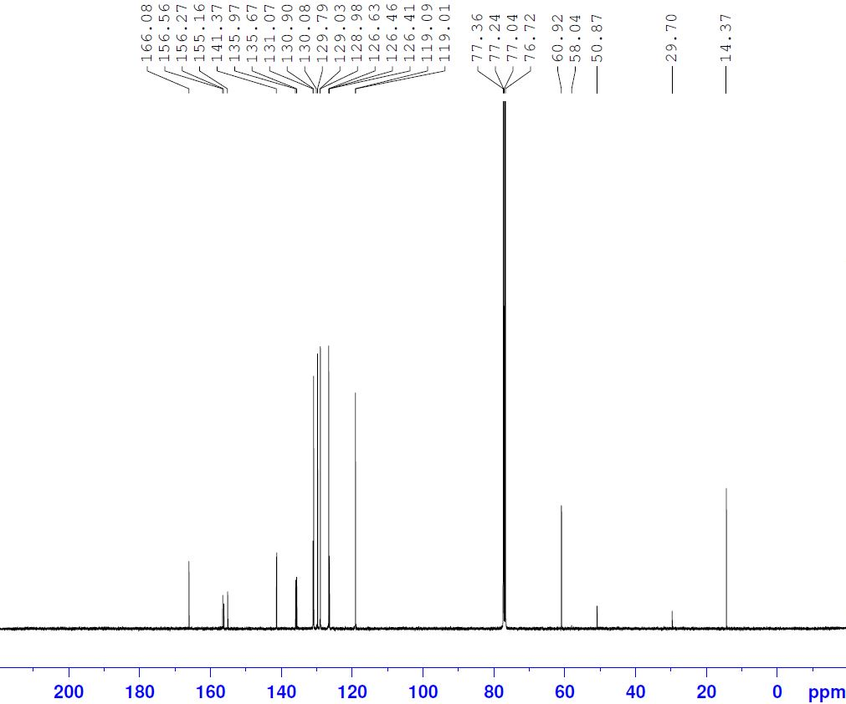
Fig. 110: ¹³C-NMR spectrum of compound 6a (CDCl₃)
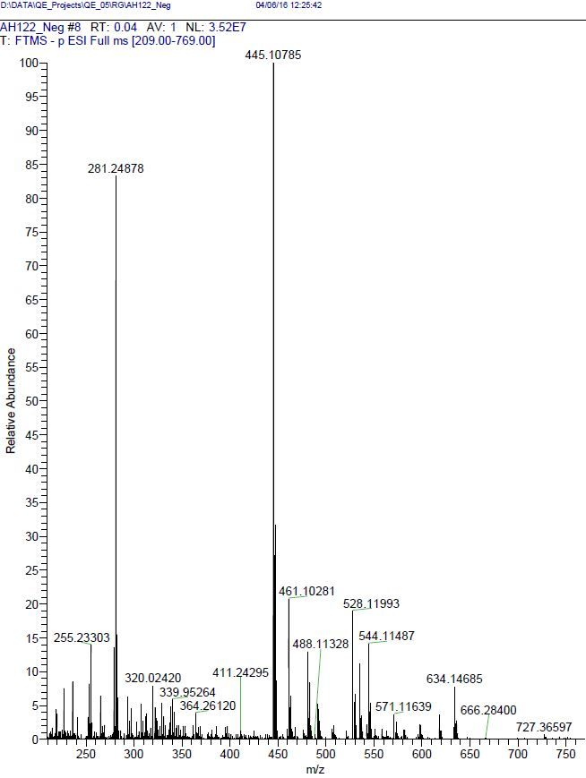
Fig. 111: HRMS of compound 6a

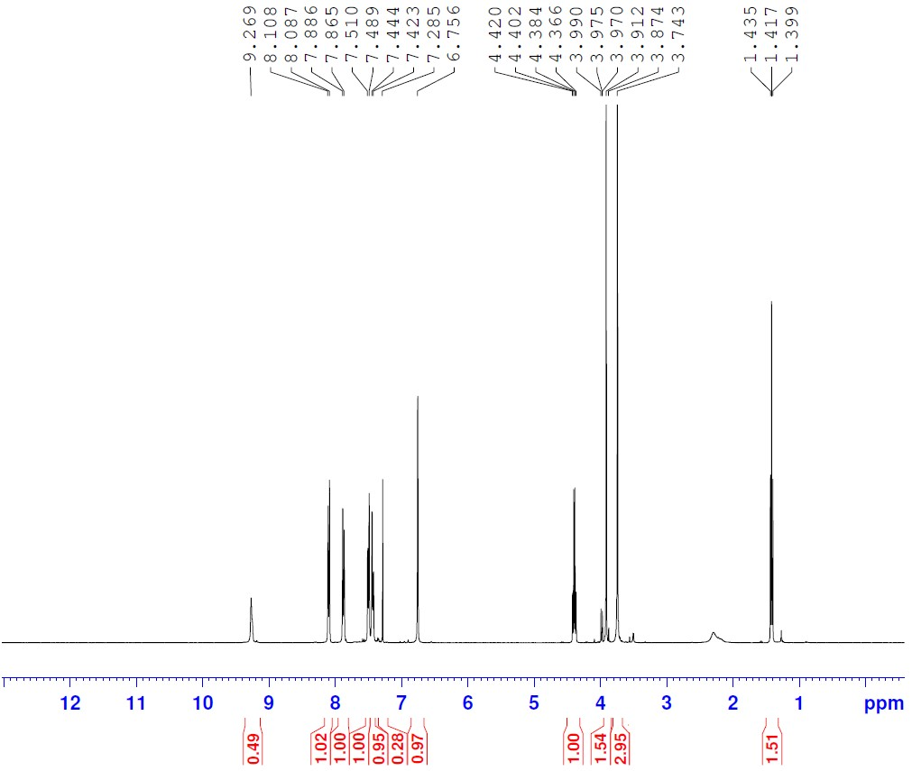
Fig. 112: ¹H-NMR spectrum of compound 6b (CDCl₃)
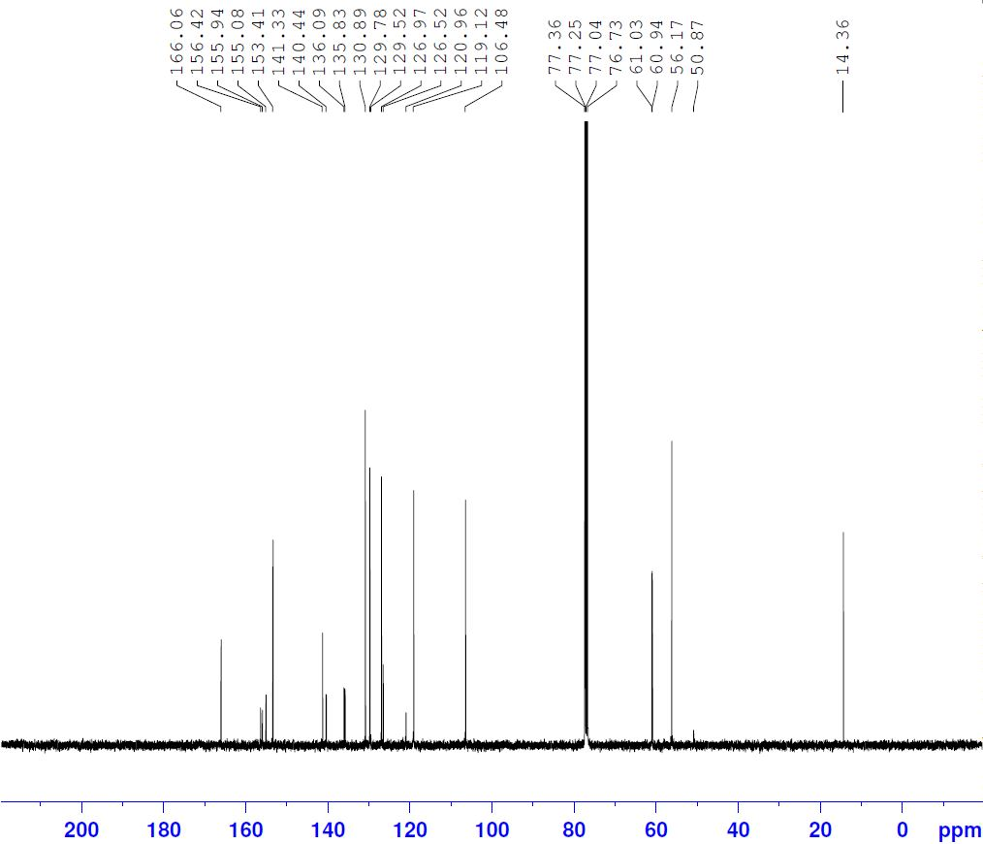
Fig. 113: ¹³C-NMR spectrum of compound 6b (CDCl₃)
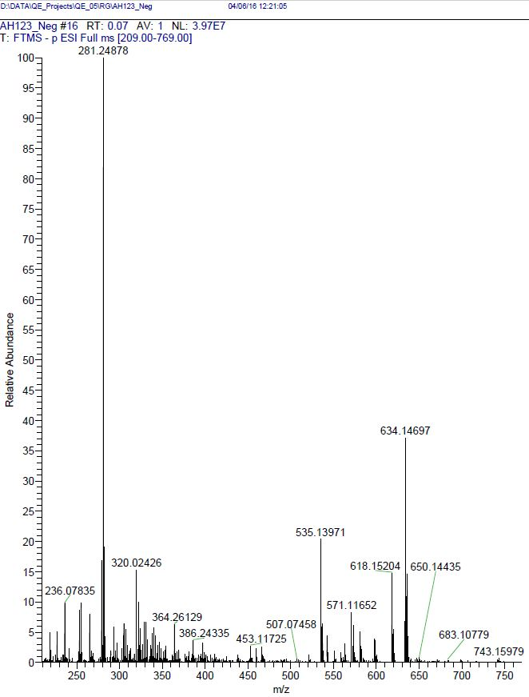
Fig. 114: HRMS of compound 6b

3.2. Biology
    - Screening of anti-inflammatory activity
Adult male albino rats, weighing (180–200 g) from the animal house in Minia University were used for this experiment. All animal procedures were performed in accordance with Animal Care Community, Minia University, Egypt (Permit Number: MPH-12-020). The animals were divided into groups (five animals each) and deprived of food but not water 24 h before the experiment. Using carrageenan, the anti-inflammatory activity of the newly synthetized compounds was studied. The tested compounds 4a-x, 5a-x, 6a,b and indomethacin were suspended in carboxymethyl cellulose (CMC) solution (0.5% w/v in water). The suspension was given by intraperitoneal route in a dose level of (20 mmol/kg). In a similar way, control animals were treated with CMC solution (0.5% w/v in water). Injection into the subplantar region of the right hind paw was done after 30 min with freshly prepared 1% carrageenan solution (0.1 ml) in normal saline in accordance of the method of Winter et al. Each left hind paw of the rats was injected by an equal volume of saline. Vernier celiper (SMIEC) was used to detect the thickness of right paw directly before and after 1, 2, 3, 4 and 5 h intervals after carrageenan injection. The percentage decrease in edema thickness induced by carrageenan was used to calculate the anti-inflammatory activity of the tested compounds and indomethacin.
3.2.2. Screening of ulcerogenicity
The rats were sacrificed by decapitation after measuring the anti-inflammatory activity. Further, the stomachs were removed, collected, opened along the greater curvature, washed with distilled water and cleaned gently by putting in saline solution. A magnifying lens was used to examine the mucosal damage for each stomach and to detect the presence of macroscopically visible lesions. If any lesions are present in each stomach, they were counted and recorded. Ulcers were classified into levels; level I, II and III according to their area in mm² as previously discussed.
The data are expressed as mean ± S.E.M and the one way ANOVA test was applied to determine the significance of the difference between the control group and rats treated with the tested compounds.
3.2.3. Histopathological investigation
The slides for histopathological investigation were prepared using the reported procedures for examination of ulcers under light microscope.[32] Wax was scratched around section with a needle in order to identify site of the slide on which the section was applied. Further, hydrated sections were dewaxed by using graded alcohols to water. Slides were haematoxylin stained for 5–7 min, tap water washed for 5 min until sectioning and immersed for 5–10 s in solution of (1% HCl in 70% alcohol). After that the slides were washed well with tap water for 10–15 min and stained with 1% Eosin for 10 min. The slides were then washed with running tap water for 1–5 min. Alcohol was then used to dehydrate slides. They were cleaned by xylene, covered by glass cover using Canada balsam and then examined under microscope.
    - TACE inhibitory activity
Cell culture [33]
Cell Lines Jurkat Clone E6-1 cells were thaw from liquid nitrogen, cells were cultured using RPMI 1640 (Invitrogen/Life Technologies) supplemented with 10% Fetal Bovine Serum (FBS) (Gibco,), 10 µg/mL of insulin (Sigma), and 1% penicillin-streptomycin. All of the other chemicals and reagents were from Sigma, or Invitrogen. Cells were plated (cells density 10,000 cells/well) in a volume of 100 µL complete growth medium + 100 µL of the tested compound per well in a 96-well plate for 72 h before the enzyme assay for TACE.
TACE inhibitory assay [34]
The in vitro TACE inhibitory activities of compounds 5a, 5f, 5h, 5i, 5k, 5p, and 5u were measured using colorimetric assay kit (Biovision, Inc.) on Jurkat Clone E6-1 cell line according to manufacturer’s directions. Growing cells counted and seeded at the appropriate densities into 96-well microtiter plates. Cells then were incubated in a humidified atmosphere at 37˚C for 24 h. The standards, the tested compounds, and the reagents were diluted to designated concentrations and added in order listed in (Table). The plate was incubated at 37˚C for 60 min, while TACE Assay Developing Solution was prepared. Stop TACE reaction by adding 50 µL of the developing solution per well, and the plate was incubated at room temperature (18-25˚C) for another 10-15 min. Optical density (O.D.) was measured at 405 nm using 96-well microplate reader. Results for each compound are reported, at 10 µM concentration, as the percent inhibition of the treated cells compared to that of the untreated control cells. All reagents, samples and standards were prepared as instructed. Standard or sample 100 μL was added to each well and was incubated for 2.5 h at room temperature. Prepared biotin antibody 100 μL was added to each well and was incubated for 1 h at room temperature. Prepared Streptavidin 100 μL solution was added and incubated for 45 min at room temperature. TMB One-step substrate reagent (100 μL) was added to each well and incubated for 30 min at room temperature. Finally, stop solution (50 μL) was added to each well and read at 450 nm immediately.

Table 7: Addition order of the standards, the tested compounds and the reagents in TACE assay.
Reagent | Blank wells | Sample
Test sample / standard | -- | 100 µL
Prepared biotin antibody | 100 µL | 100 µL
Prepared streptavidin solution | 100 µL | 100 µL
TMB One-Step Substrate | 100 µL | 100 µL
Stop Solution | 50 L | 50 L
MMP-1 inhibitory assay
All materials and prepared reagents were equilibrated to room temperature (18 - 25°C) prior to use. It was recommended to assay all standards, controls and samples in duplicate. Add 100 μL of each standard and sample into appropriate wells, then it was covered well and incubated for 2.5 h at room temperature or overnight at 4°C in addition to gentle shaking. Discard the solution and wash 4 times with 1X wash solution (washing was done by filling wash solution (300 μL) to each well using a multi-channel pipette or auto washer). Complete removal of liquid at each step was essential to good performance. After the last wash, any remaining liquid was removed by aspirating or decanting. The plate was inverted and blotted against clean paper towels. 100 μL of 1X Biotinylated MMP1 detection antibody was added to each well and incubated for 1 hour at room temperature with gentle shaking. The solution was discarded and the wash step was repeated. 100 μL of 1X HP-Streptavidin solution was added to each well then incubated for 45 minutes at room temperature with gentle shaking. The solution was discarded and the wash step was repeated. TMB One-Step Substrate Reagent 100 μL was added to each well then incubated for 30 minutes at room temperature in the dark with gentle shaking. Stop Solution 50 μL was added to each well and read at 450 nm immediately.

    - Docking study at TACE active site
Docking simulation study is performed in Medicinal Chemistry Department, Faculty of pharmacy, Assiut University using Molecular Operating Environment (MOE®) version 2014.09, Chemical Computing Group Inc., Montreal, Canada. The computational software operated under “Windows XP” installed on an Intel Pentium IV PC with a 1.6 GHz processor and 512 MB memory.
Target compounds optimization
The target compounds were constructed into a 3D model using the builder interface of the MOE program. After checking their structures and the formal charges on atoms by 2D depiction, the target compounds were subjected to a conformational search. All conformers were subjected to energy minimization, all the minimizations were performed with MOE until a RMSD [ Root Main Square Deviation ] gradient of 0.01 Kcal/mole and RMS distance of 0.1 Å with MMFF94X force-field and the partial charges were automatically calculated. The obtained database was then saved as MDB file to be used in the docking calculations.
Optimization of the enzymes active site
The X-ray crystallographic structure of the target catalytic domain of TACE [pdb: 2a8h] was obtained from Protein data bank. The enzyme was prepared for docking studies by firstly; hydrogen atoms were added to the system with their standard geometry. The atoms connection and type were checked for any errors with automatic correction. Selection of the receptor and its atoms potential were fixed. Finally, docking of the target molecules to TACE active site.

