## **A novel approach for apoptosis and caspase-3 inhibition using new candidates of 1,5-Diaryl triazole-3-carboxamides**

## **Adel M. Abdelhakem**, **1\*** **El-Shimaa M. N. Abdelhafez, 1 Samar H. Abbas,1 Sara Mohamed Naguib Abdel Hafez, 2 Walaa Yehia Abdelzaher, 3** **Omar M. Aly, 4**

*1* Department of Medicinal Chemistry, Faculty of Pharmacy, Minia University, Egypt,

2 Department of Histology and Cell Biology, Faculty of Medicine, Minia University, Egypt,

3 Department of Pharmacology, Faculty of Medicine, Minia University, Egypt

*4* Department of Medicinal Chemistry, Faculty of Pharmacy, Port Said University, Egypt

*Correspondence: [pharmacist_adel2010@yahoo.com](mailto:pharmacist_adel2010@yahoo.com), Postal address: 61722

**Spectra of compound 8a:**

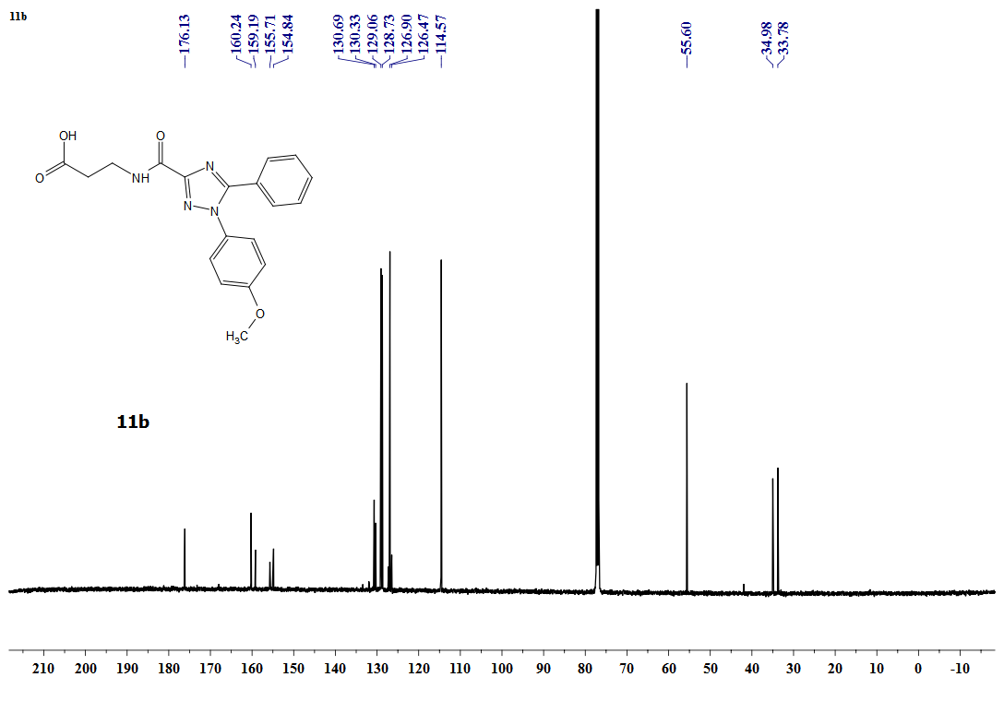

8a

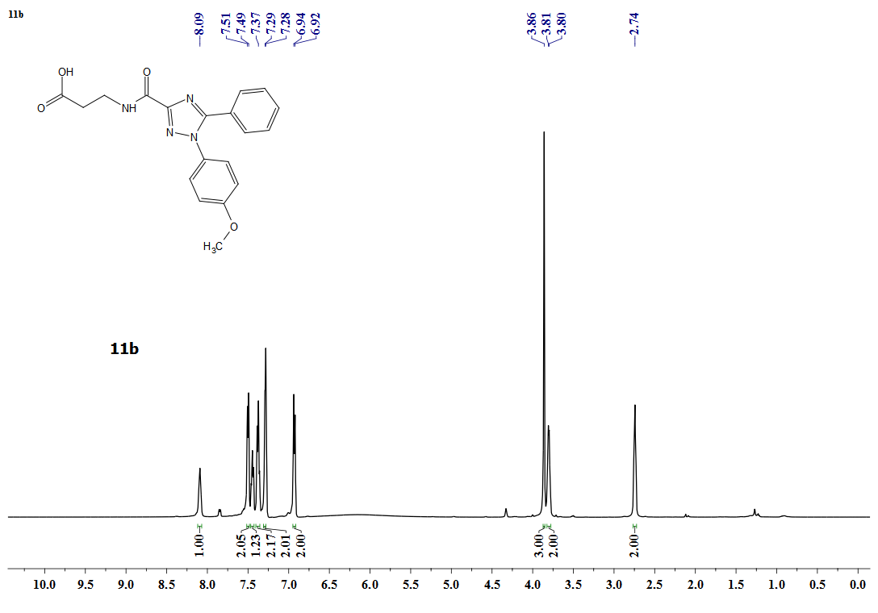

8a

**Spectra of compound 8b:**

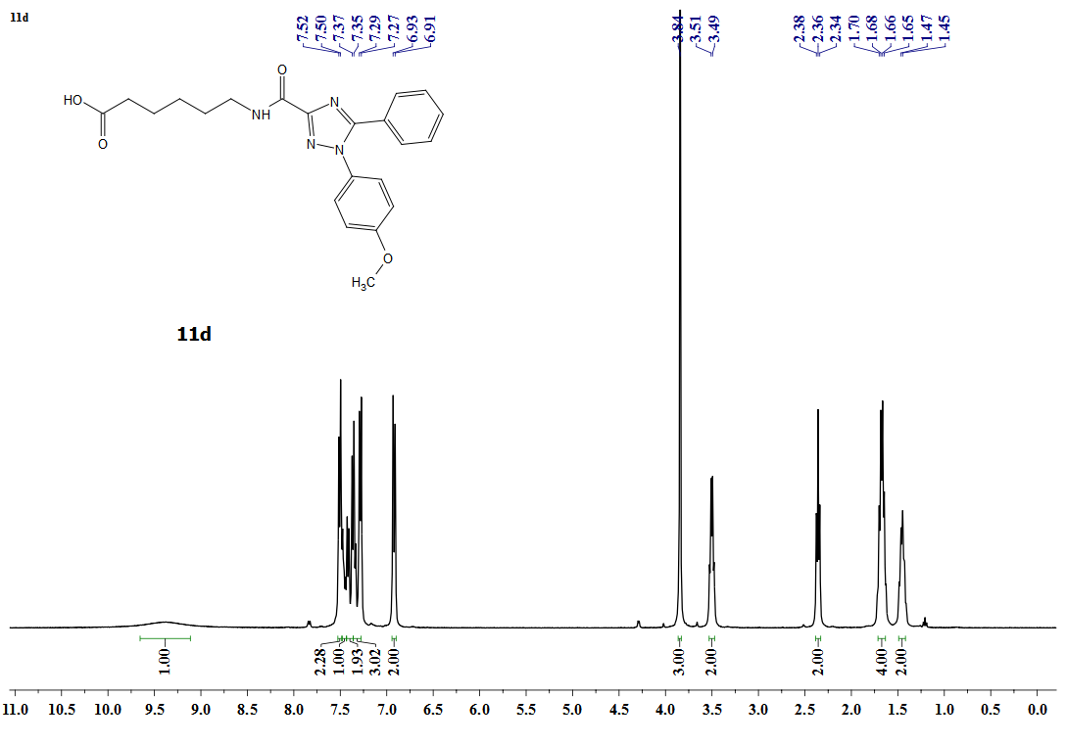

8b

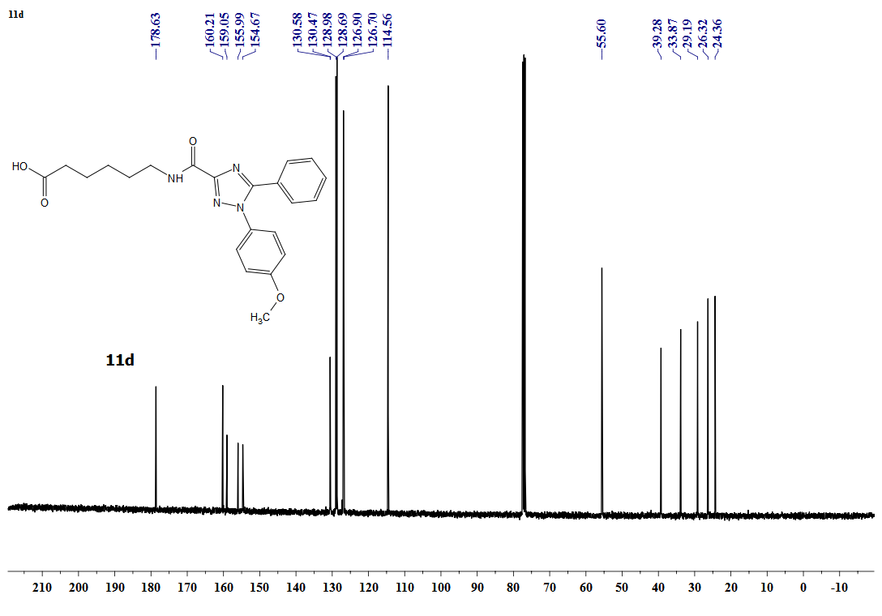

8b

**Spectra of compound 9a:**

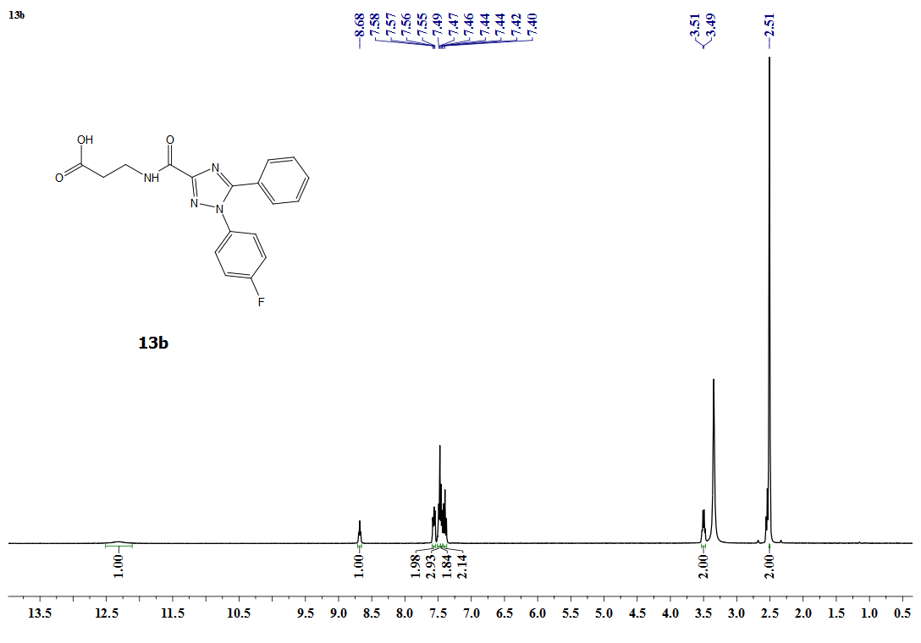

9a

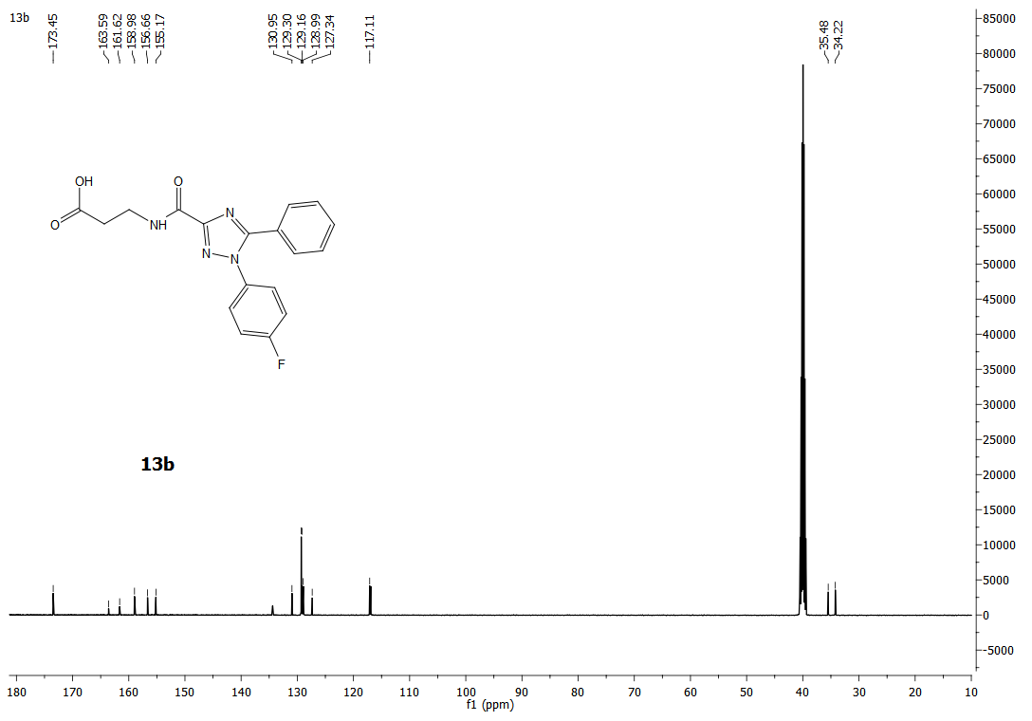

9a

**Spectra of compound 10a:**

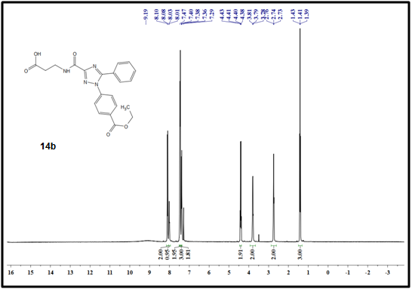

10a

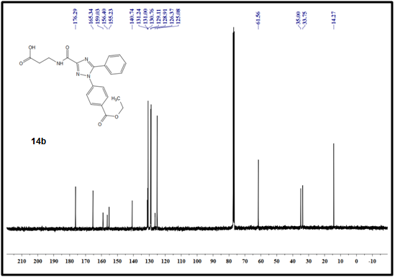

10a

**Spectra of compound 10b:**

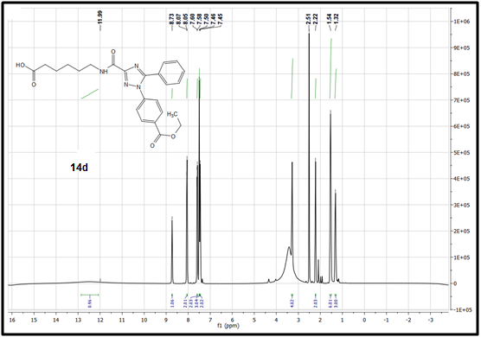

10b

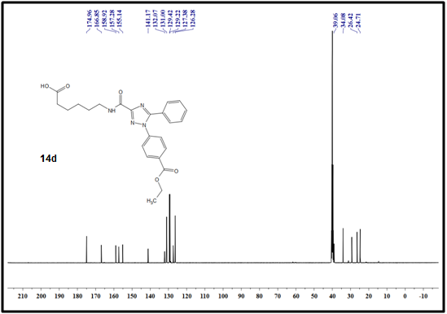

10b

**Table S1**: Biomarkers’ expression in case of antiapoptosis

|  |  |  |  |
| --- | --- | --- | --- |
| **\*Biomarker** | **effect during antiapoptosis** | **Liver** | **Ovary** |
| General | Inhibition | Serum TNFα,[1] MDA[2] | |
| Activation | SOD[3],GSH[4], Nox[5] | |
| Specific | Inhibition | ALT, AST[6] | **------** |
| Activation | **------** | AMH[7] |

\***TNF** = Tumor necrosis factor, **MDA** = Malondialdehyde, **SOD** = Superoxide dismutase

**GSH** = Glutathione, **NOx** = NADPH oxidase, **ALT** = Alanine aminotransferase

**AST** = Aspartate aminotransferase, **AMH** = Anti-Mullerian hormone

**Table S2**: Mean number of immune stained for caspase-3 in liver and ovary cells

|  |  |  |
| --- | --- | --- |
| **Group** | **The mean number of caspase-3 immuno-stained cells** | |
| **Liver** | **Ovary** |
| **Sham** | 0.2857±0.1844 | 1.000 ± 0.3780 |
| **I/R** | 22.857±0.9110 | 84.500 ± 1.165*** |
| **NAC** | 8.857±0. 0.4608 | 40.625± 1.322 |
| **8a** | 4.714 ± 0.6801 | 18.500 ± 1.637 |
| **8b** | 15.286± 0.5654 | 69.375± 0.8647*** |
| **9a** | 15.143± 0.7377 | 76.625± 1.322*** |
| **10a** | 4.000 ±0.5774 | 25.625 ± 1.068 |
| **10b** | 14.857±0. 0.2608 | 73.000 ±0.8864*** |

Values are mean X ± SE for five animals in each group.

*Significance (P value) are *** P1<0.001,*** P2<0.001, *** P3<0.001,*** P4<0.001, *** P5<0.001, ** P6<0. 01, *** P7<0.001, *** P8<0.001,*** P9<0.001, *** P10<0.001,*** P11<0.001, ns P12 >0.05, P13<0.001, ns P14>0.05, *** P15<0.001,*** P16<0.001, ns P17>0.05,*** P18<0.001* *P19<0.001,mNs P20 >0.05,*** P21<0.001*

\**P*<0.05 significant; \*\**P*<0.001 highly significant by the student *t*-test.

*P*1: Comparison between sham group I and ischemic reperfusion group.

*P*2: Comparison between sham group and drug 1

*P*3: Comparison between sham group and drug 2

*P*4: Comparison between sham group I and drug 3.

*P*5: Comparison between sham group and drug 4

*P*6: Comparison between sham group and drug 5

*P*7: Comparison between ischemic reperfusion group and drug 1.

*P*8: Comparison between ischemic reperfusion group and drug 2

*P*9: Comparison between ischemic reperfusion l group and drug 3

*P*10: Comparison between ischemic reperfusion group and drug 4.

*P*11: Comparison between ischemic reperfusion and drug 5

*P*12: Comparison between drug 1 and drug 2

*P*13: Comparison between drug 1 and drug 3

*P*14: Comparison between drug 1 and drug 4

*P*15: Comparison between drug 1 and drug 5

*P*16: Comparison between drug 2and drug 3

*P*17: Comparison between drug 2 and drug 4

*P*18: Comparison between drug 2 and drug 5

*P*19: Comparison between drug 3 and drug 4

*P*20: Comparison between drug 3 and drug 5

*P*21: Comparison between drug 4 and drug 5

Values are mean X ± SE for 5 animals in each group.

*Significance (P value) are *** P1<0.001,*** P2<0.001, *** P3<0.001,*** P4<0.001, *** P5<0.001, ** P6<0. 01, *** P7<0.001, *** P8<0.001,*** P9<0.001, *** P10<0.001,*** P11<0.001, ns P12 >0.05, P13<0.001, ns P14>0.05, *** P15<0.001,*** P16<0.001, ns P17>0.05,*** P18<0.001* *P19<0.001,mNs P20 >0.05,*** P21<0.001*

\**P*<0.05 significant; \*\**P*<0.001 highly significant by the student *t*-test.

*P*1: Comparison between sham group I and ischemic reperfusion group.

*P*2: Comparison between sham group and drug 1

*P*3: Comparison between sham group and drug 2

*P*4: Comparison between sham group I and drug 3.

*P*5: Comparison between sham group and drug 4

*P*6: Comparison between sham group and drug 5

*P*7: Comparison between the ischemic-reperfusion group and drug 1.

*P*8: Comparison between the ischemic-reperfusion group and drug 2

*P*9: Comparison between the ischemic-reperfusion l group and drug 3

*P*10: Comparison between the ischemic-reperfusion group and drug 4.

*P*11: Comparison between ischemic reperfusion and drug 5

*P*12: Comparison between drug 1 and drug 2

*P*13: Comparison between drug 1 and drug 3

*P*14: Comparison between drug 1 and drug 4

*P*15: Comparison between drug 1 and drug 5

*P*16: Comparison between drug 2and drug 3

*P*17: Comparison between drug 2 and drug 4

*P*18: Comparison between drug 2 and drug 5

*P*19: Comparison between drug 3 and drug 4

*P*20: Comparison between drug 3 and drug 5

*P*21: Comparison between drug 4 and drug 5



**Figure S1**: Caspase inhibition of the triazole conjugates



**Figure S2**: Design of the target 1,2,4-triazoles.

|  |  |
| --- | --- |
| **(i)** | **(ii)** |

**Figure S3:** A 2D representation of the docking poses of compound 10a(a) **(i)** and the co-crystallized ligand NA3 **(ii)** on caspase-3 catalytic site

|  |
| --- |
|  |
| Figure S4: Representative photomicrographs of sections of the ovary of compound 9a group showing: A) Disturbed lobular architecture (star) with congested blood vessels (BV). B) thick epithelial germinal layer (arrow). Focal ovarian stromal loss (star) is seen. Some ovarian follicles display severe loss of their follicular cells (F) without their ova. C) Atretic follicle (black star) with separation of its follicular cells (arrow).Corpus lutein (CL) with severe degeneration with congested blood vessels (BV). Stromal cells (yellow star) are arranged in a cluster and show pale cytoplasm. H&E, scale bar: A1 X500 μm; B , C X 200μm.   |  | | --- | |  | | **Figure S5:** Photomicrographs of sections of the ovary of compound **8b** group showing **A**) Disturbed lobular architecture (star). Notice the congestive blood vessels (BV). **B**) Corpus lutein (CL) with severe interstitial hemorrhage (hg). Notice the abundant amount of hemosiderin pigment (arrow). **C**) Atretic follicle (F) with severe degeneration. Notice the intraluminal follicular cells (circle) and massive follicular vacuolations (v). H&E, scale bar: X500 μm; B, C X 200 μm. | |  | | | **Figure S6:** Photomicrographs of sections of the ovary of **10b** group showing **A)** Disturbed lobular architecture (star). Notice the atretic follicle (F) and the interstitial hemorrhage (hg). **B**) Dilated congested blood vessels (arrows). Stroma shows severe atretic follicle (F). The proliferation of stromal cells (st) is noticed. **C**) Sever dilated blood vessels (BV) surrounded by perivascular inflammatory cells (circle). Homogenous acidophilic material appears in the ovarian stroma (CD). Corpus luteum (CL) with severe vacuolations (box areas). Notice the severe demarcations (arrow) between aggregated corpus lutein. E) H&E, scale bar: A, B X500 μm; C, D X 200μm. | | |  | | | **Figure S7**: Representative photomicrographs of ovary sections for all groups showing A) Sham group with faint blue staining for Perl’s iron stain (circle). B) Ischemic reperfusion group showing more cytoplasmic staining (circle). C) Compound 9a group showing more cytoplasmic staining (circle) than the sham group. D) Compound showing iron cytoplasmic staining more than the normal group (circle). E) Compound 10a group showed more iron staining (circle) than the ischemic-reperfusion group. F) Compound 10b group showing less cytoplasmic staining (circle) than the ischemic-reperfusion group. G) Compound 8a group showing more cytoplasmic iron staining (circle). H) NAC group showing bluish cytoplasmic staining more than the sham group. Perl’s stain, scale bar: X500 μm | |     **Figure S8:** Representative photomicrographs of caspase -3 immunostained liver sections: **A**) sham group showing hepatocytes with a negative reaction. **B**) I/ R group showing strong and intense cytoplasmic reaction in hepatocytes (arrows). **C & D**) compounds **8a** and **10a** groups showing faint hepatocyte cytoplasmic reaction (arrows). **E&F&J**) Compounds **10b, 8d**, and **11d** showing more cytoplasmic caspase reaction in hepatocytes (arrows). **H)** **NAC** group showed more cytoplasmic brown coloration for caspase than the sham group. Caspase-3, X 400.    **Figure S9:** Representative photomicrographs of rat ovarian tissue immuno-stained for caspase for all groups showing: **A**) Sham group with negative expression. **B**) I/R group showing intense and massive cytoplasmic immunoreaction in ovarian cells (arrow). C) **9a** group showed more cytoplasmic reaction (arrow) in ovarian cells than in the sham group. **D**) **8b** group showing more cytoplasmic reaction. E) **10a** showing less cytoplasmic immunoreaction (arrow). F) **10b** showing more cytoplasmic caspase reaction (arrow). **G**) **8a** group showing faint cytoplasmic reaction (arrow). **H) NAC** groupshowed more cytoplasmic expression for caspase-3 than the sham group. Immuno-histochemistry, counterstained with H, scale bar X50 μm. |
|  |
| **Figure S10:** Photomicrographs of sections in the ovary of the sham group showing: **A)** dome-shaped projection of the ovarian cortex, covered by germinal epithelium (arrowhead). Numerous follicles of different sizes and developmental stages ranging from primary follicles (black arrow) to mature Graafian follicles (star) are observed. The medulla shows multiple stromal cells (green star) with blood vessels (dotted arrow). **B)** Higher magnification of the previous photomicrograph showing secondary follicle (sc) with a primary oocyte (O) surrounded by zona pellucida (arrow). Theca Externa (Ex), and theca interna (In), are seen surrounding the secondary follicle. Note the antral space containing liquor (L). Also note the granulosa cells (g). Corpus lutetium (cl) is seen in the ovarian stroma with lightly stained lutein cells.H&E, scale bar: A X500 μm; B X 200μm. |

Regarding the I/R group, the ovarian cortex is covered by a thick germinal epithelial cell layer containing a variable amount of atretic follicles. Massive stromal hemorrhage and focal areas of stromal loss were frequently noticed. The stroma also showed numerous thick congested, ruptured blood vessels and abundant vacuolations. The stroma also displayed hyaline eosinophilic material. Atretic follicles appeared and showed desquamated intraluminal cells. No ova could be seen inside this atretic follicle. Most follicular cells became either dense or lost. Atretic follicles showed a wide antrum, the irregular lining of their follicular cells and wide spacing between its layers. Follicular cell vacuolations and hyaline eosinophilic material were demonstrated among the atretic follicle. The corpora lutea in this group appeared with severe hemorrhage, inflammatory cells, and multiple dense nuclei. (**Figure S10**).

|  |
| --- |
|  |
| **Figure S10:** Photomicrographs of sections of **(A-H)** ischemia/reperfusion group and NAC group showing:   1. the ovarian cortex is covered by a thick germinal epithelial cell layer (red arrow) and contains a variable number of atretic follicles (black arrow). Notice the massive stromal hemorrhage (hg). **B)** Focal areas of stromal loss (curved arrow). The stroma shows numerous congested rupture blood vessels (stars) and abundant vacuolations (V). Thicken blood vessels (BV) is also found. The stroma also displays hyaline eosinophilic material (cd). **C)** Corpus luteum with severe hemorrhage (hg) and dense nuclei. D) Corpus luteum shows inflammatory cells (black circle). Atretic follicles appear with intraluminal detached follicular cells (green circle). No ova can be seen inside this atretic follicle. Most follicular cells become dense. Notice the follicular cell loss. The stroma shows thickened blood vessels (arrows); contains hypertrophied smooth muscle cells. Most stromal cells appear with only nuclethatth lostheirts cytoplasm (star). **E**) Two atretic follicles show wide antrum, the irregular lining of their follicular cells and wide spacing between its layer (S). Notice the vacuolations in follicular cells (V). Hyaline eosinophilic material (star) is shown among the atretic follicles. Notice the severe loss of follicular and stromal (star) cells. **H)** NAC group showing disturbed lobar architecture with interstitial hemorrhage.H&E, scale bar: A X500 μm; B, C, D, E X 200μm. |

**References**

[1] Li, K., et al., *Current and emerging biomarkers of cell death in human disease.* BioMed research international, 2014. **2014**.

[2] Marrocco, I., F. Altieri, and I. Peluso, *Measurement and clinical significance of biomarkers of oxidative stress in humans.* Oxidative medicine and cellular longevity, 2017. **2017**.

[3] Kanamori, A., et al., *Superoxide is an associated signal for apoptosis in axonal injury.* Brain, 2010. **133**(9): p. 2612-2625.

[4] Enns, G.M. and T.M. Cowan, *Glutathione as a redox biomarker in mitochondrial disease—Implications for therapy.* Journal of clinical medicine, 2017. **6**(5): p. 50.

[5] Crosas-Molist, E. and I. Fabregat, *Role of NADPH oxidases in the redox biology of liver fibrosis.* Redox biology, 2015. **6**: p. 106-111.

[6] Luedde, T., N. Kaplowitz, and R.F. Schwabe, *Cell death and cell death responses in liver disease: mechanisms and clinical relevance.* Gastroenterology, 2014. **147**(4): p. 765-783. e4.

[7] Nilsson, E.E., et al., *Inhibitory actions of Anti-Müllerian Hormone (AMH) on ovarian primordial follicle assembly.* PloS one, 2011. **6**(5).